Sustainable Heritage Governance: Focusing on the Heritage Utilisation Projects in South Korea

Yaena Lee
Candidate number 212716

School of History, Art History and Philosophy
Heritage
September 2021
Contents
Abstract ⅱ
List of Abbreviations ⅲ
List of Figures ⅳ
Chapter 1- INTRODUCTION 1
1.1. Background and Purpose 1
1.2. Methodology and Contents 4
Chapter 2- REVIEW OF LITERATURE 5
2.1. Definition and Scope of Heritage 5
2.2. Socio-cultural Significance of Heritage 7
2.2.1. The New Roles and Significance of Heritage: A Global Context 8
2.2.2. The New Roles and Significance of Heritage: South Korea 9
2.3. Heritage Policies in Various Countries 11
2.3.1. The Case of Japan’s Heritage Policy 11
2.3.2. The Case of France’s Heritage Policy 13
2.3.3. The Case of the UK’s Heritage Policy 15
2.4. Understanding Governance in Heritage sector 17
2.4.1. A Definition of Governance 17
2.4.2. Background of the Emergence of Governance 18
2.4.3. The Definition and Importance of Heritage Governance 20
Chapter 3- CASE STUDY 22
3.1. Case Study 1: Heritage Night Project in Seongbuk 22
3.1.1. Description of the project 22
3.1.2. The Governance Structure and Roles of Actors in the Project 25
3.2. Case Study 2: Wolbong Seowon Heritage Project 28
3.2.1. Description of the project 28
3.2.2. The Governance Structure and Roles of Actors in the Project 30
3.3. Interviews with Heritage Project Managers 33
Chapter 4- FINDINGS 41
Chapter 5- CONCLUSION 45
Bibliography 48
Abstract

Since 2010, the government of South Korea has promoted various beneficial uses of designated heritage buildings and objects as a major national initiative. Heritage utilisation is an act in contrast to state-led management that includes conservation or preservation and is mainly carried out in the form of a project that allows people to share and enjoy the value of heritage through participation and cooperation between individuals and communities. This new trend seems to highlight heritage governance, which is based on the networking of various actors as a principal method for enabling sustainable heritage utilisation projects.
Using interviews with the project managers of two heritage projects in South Korea – the Heritage Night project in Seongbuk and the Wolbong Seowon heritage project – this research aims to explore factors that can lead to the development of meaningful projects with the effective and sustainable participation of actors. This study ultimately aims to contribute to the establishment of heritage governance and the discussion of participation in heritage sectors by focusing on the roles and limitations of each entity involved, including central and local governments, private organisations and civil society in South Korea.

List of abbreviations

ACA Agency for Cultural Affairs
AHD Authorised Heritage Discourse
CHA Cultural Heritage Administration
DCMS Department for Digital, Culture, Media and Sport
GBP British Pound Sterling
ICH Intangible Cultural Heritage
ICOMOS International Council on Monuments and Sites
NGO Non-Governmental Organisation
OECD Organisation for Economic Co-operation and Development
OUV Outstanding Universal Value
UNESCO United Nations Educational, Scientific and Cultural Organisation

List of Figures
Figure. 1: Infographic of the value and impact of heritage and the historic Environment, 2014 (Source: Historic England website) 7

Figure. 2: The primary objectives of Japan Heritage (Source: Agency for Cultural Affairs of Japan website) 12

Figure. 3: Malvy report: Relying on French Heritage to Boost Tourism, 2014 (Source: France Diplomacy) 14

Figure. 4: the HLF project, ‘East Cleveland’s Industrial Heartland’ memorial photo, 2018 (Source: East Cleveland Industrial Heartland Website) 16

Figure. 5: Children who participate in Heritage Night and look around the Seoul City Wall, 2018 (Source: Heritage Night project in Seongbuk website) 24

Figure. 6: Heritage Night guided tour with volunteers at Simujang House, 2018 (Source: Heritage Night project in Seongbuk website) 24

Figure. 7: Community member meeting(left) and Public-Private workshop(right) for the Heritage Night at Seongbuk Cultural Centre, 2018 (Source: Seongbuk Cultural Centre website) 27

Figure. 8: Panoramic view of Wolbong Seowon, 2019 (Source: Wolbong Seowon website)
28

Figure. 9: Wolbong Seowon programmes for children and young students, 2017 (Source: Wolbong Seowon website) 30

Figure. 10: Nervesil Villagers with the meals they cooked, 2016 (Source: Wolbong Seowon website) 32

Figure. 11: The workshop among participants at Wolbong Seowon, 2016 (Source: Wolbong Seowon website) 32

Chapter 1

INTRODUCTION

  - . Background and Purpose
Heritage has unique and outstanding cultural characteristics. The heritage embodying various values provides a richness in human life. However, due to industrialisation and urbanisation, tangible and intangible heritage is rapidly disappearing around us, and in order to prevent these situations and preserve their heritage, states use regulatory policies and cooperate internationally through conventions and guidelines. These activities have focused on preserving and protecting the external and physical elements of heritage and thus miss opportunities for its meanings or values to exert influence and isolating heritage as a special entity separate from everyday life. Additionally, states sometimes use designated heritage as a political means of promoting people's solidarity and securing legitimacy for the government’s ruling forces, while presenting heritage as a symbol of the people's permanence and superiority.
Nevertheless, heritage is accumulated from various cultural experiences formed throughout history and contains the adaptability and creativity of mankind, which has actively responded to environmental changes. Heritage conveys the lives and achievements of mankind as these connect the past with the present. Since heritage has no inherent in value on its own but is given values and meanings by human beings living with it, it may deviate from the heritage category when the heritage’s importance to people is diminished or when people are no longer able to sympathise with its meaning. In other words, historic buildings, objects, places and skills can only become heritage when they influence human life and provide utility for people.
As the significance of heritage granted in societies and communities has grown more than the value of heritage stipulated by the state or experts, local people have been actively participating in traditional heritage management activities such as conservation and restoration. In addition, heritage projects, including oral history work, heritage tours, and educational programmes for students, have been developed. This trend seems to be taking place in various countries and societies, whether led by the state or through voluntary participation from civil society. This means that the paradigm is shifting from the traditional perspective that heritage should be maintained as it exists and delivered to future generations to the view that more modern uses need to be established by promoting the participation of various people and establishing close relationships with society.
In South Korea, a community-based approach to enjoying heritage with the general public has become more active, and it has moved forward from state-led management to collaborate with local government and the private sector. Among these initiatives, the most notable is the ‘Cultural Heritage Utilisation Project’, which has been in full swing since 2010. The project is granted funding by the central government to support the implementation costs of programmes carried out by local governments and private organisations. In 2020, a total of 386 projects are being delivered nationwide, each of which is planned to include events and performances for local heritage tourism or educational programmes through which locals and students can discover the value of heritage and learn its significance. The emergence of heritage utilisation projects has also highlighted the role of governance, which values a collaborative structure based on the participation and cooperation participants with various interests. This is because projects to discover and spread the value of heritage are difficult to plan and carry out through the functions and roles of the existing cultural heritage governing body, the government and experts.
Heritage utilisation has been made use of in many countries in the form of various projects or national policies, but it seems that there has not been much academic research on this yet. Compared to heritage tourism research, the discussion of more fundamental methods of heritage uses, which include education, enjoyment, and well-being, have not been an active area of study. Nevertheless, Clark has argued that the heritage project in the UK, nationally supported by the Heritage Lottery Fund (HLF), has the advantage of broadening the concept of heritage and bringing ordinary people into the heritage field. Barile and Saviano have also stressed the need for a change to governance in a way that considers enhancement and sustainability of heritage values from a dominant perspective that focuses on heritage's conservation and protection in relation to Italian cultural heritage management.
Therefore, this study aims to derive the necessary factors for better governance, focusing on the heritage utilisation projects in South Korea. The cases for analysis are the ‘Heritage Night project in Seongbuk’ and the ‘Wolbong Seowon (Confucian Academy) Heritage Project’. These projects have been going on for more than three years, and are characterised by the fact that several participants, especially local governments, civic groups, villagers and owners, have been building and operating governance together. As a result, this paper seeks to draw meaningful implications for heritage projects by analysing Korean cases, presupposing that governance should precede the heritage projects.

To achieve this aim, two research questions have been chosen:
1. What actors are involved in the heritage projects in South Korea, and what functions do they have?
2. Based on the implications of the case studies, what factors are needed to effectively develop heritage projects in terms of governance?
1.2. Methodology and Contents
This is a qualitative research study that uses a literature review, case studies and structured interviews. Qualitative research has the advantage of providing contextual understanding by identifying various aspects of the phenomena to be studied. For the study, the theoretical background of the main keywords ‒ 'heritage' and 'governance' ‒ will be discussed first by referring to literature, such as reports, articles and books. Following this, the analysis of chosen heritage project cases ‒ the 'Heritage Night project in Seongbuk' and the 'Wolbong Seowon Heritage Project' ‒ regarding participation methods and roles of actors, including the government, private sector and civil society, are presented. The case studies were compiled from project plan reports, final reports, and the local newspaper articles. Additionally, the interviews with the project managers were conducted to find out information about specific circumstances that could not be revealed in the reports. The interviews were conducted by having participants answer written questionnaires and undertake video call to supplement this questionnaire.
This study consists of a total of five chapters:
Chapter 1 is the introduction and describes the background, purpose and methodology and outlines the contents of the study.
Chapter 2 discusses what heritage is and the process of changes in policies surrounding heritage. In particular, utilisation and promotion activities that spread the value and meaning of heritage and enhance understanding within society are analysed. It also outlines the concept of governance, and more specifically, what heritage governance means.
Chapter 3 analyses the composition, role and implications of governance, focusing on the case of South Korea's heritage utilisation projects.
Chapter 4 presents the findings, and finally, Chapter 5 summarises the results based on the full content.

Chapter 2

REVIEW OF LITERATURE

2.1. Definition and Scope of Heritage
Heritage is a complex concept, and disputes and discussions continue concerning its definition and scope. Academically and theoretically, heritage has been discussed as a discourse, and practically and technically, international organisations and individual countries have defined heritage as an object of policy through conventions, charters and legislations.
Heritage in academic and sematic discussions has been recognised as a discourse in recent years. ‘Discourse’ is ‘a form of social practice’, which is organised by a society's 'situations, institutions and social structures', but inversely, it also shapes series of social knowledge and the identities of groups of people. From this view, heritage is formed by a society and individuals, but at the same time, the dominant discourse that was created in this way has a strong influence on the way of thinking of society members. In connection with this, Smith has referred to existing heritage discourse as ‘Authorised Heritage Discourse (AHD)’, which focuses on experts and governments, western countries, and tangible things such as monuments and buildings. She has also argued that ‘Critical Discourse Analysis’ can be an important tool for analysing what heritage is and what role it plays in contemporary society. Combining these points, heritage as a discourse frames heritage as a ‘process’ ‒ produced, shared and reproduced by people in a society ‒ so that it can be seen as a broad concept that includes not only certain objects, buildings, places but also thoughts, values and rituals.
On the other hand, international organisations and individual nations are drawing up technical definition of heritage that bring it into the realm of management in order to promote practical activities such as conservation, preservation and restoration. Among the international organisations concerned with heritage, the International Council on Monuments and Sites (ICOMOS) and the United Nations Educational, Scientific and Cultural Organization (UNESCO) are institutions of importance for their influence. The term ‘heritage’ appeared in Articles 1 and 2 of the ‘Convention Concerning the Protection of the World Cultural and Natural Heritage’ of UNESCO in 1972. These provisions divided heritage into cultural and natural. Cultural heritage is defined as places and objects that are of outstanding universal value (OUV) in terms of history, art or science, based on the materiality created by humans such as monuments or groups of buildings and sites. This definition, which has influenced many countries in both conventional and official literature, has been criticised for its exclusion of intangible values, such as socio-political contexts and interaction between humans, by focusing only on the specific value inherent in the heritage. International discussions have taken place since the late 1970s over whether the forms of heritage that should be preserved include only tangible things, and in 1987, the Washington Charter supplemented the material view by declaring that the qualities to be preserved include spiritual elements as well as material elements. The 'International Cultural Tourism Charter' published in 1999 also included intangible factors such as ‘past and continuing cultural practices, knowledge and living experiences’, emphasising that heritage is a broad concept. The convention adopted in 2003 referred to practices, expressions, knowledge, skills, and even communities themselves as intangible cultural heritage.
Every nation also specifies its own definitions of heritage in order to implement activities such as designation, conservation and management in line with policy efficiency and political and economic contexts. For instance, in the United Kingdom, ‘Treasure’ is the label given by the Treasure Act to objects that have historical, architectural and archaeological values, while ‘historic environment’ includes listed buildings, scheduling monuments, registering parks, gardens and battlefields and protecting wreck sites. Those are designated and managed at the national level according to the guidelines for each type. There are differences between countries, but generally, heritage as defined by the state and local governments encompasses relatively similar categories: tangible assets such as buildings, relics and archaeological sites and intangible resources including traditional skills and rituals. However, as criticised in the AHD discussion, the scope of heritage selected and managed in legal and policy areas is limited in that only those heritage objects that have been deemed important by formal, authoritative experts and institutions are recognised. Therefore, in this paper, I would like to define heritage as a comprehensive concept that includes objects, places and practices that people have shared and protected from the past and the community and oral histories that may not have been officially designated.

2.2. Socio-cultural Significance of Heritage

As discussed in the previous chapter, the concept of heritage has changed from revealing the particular values and meanings inherent in buildings and objects to emphasising the relationship between heritage and people, communities and society. The fact that the concept and scope of heritage have expanded means that in contemporary society, heritage is not only protected and preserved in its original fabric, but is also required to function as an entity that contributes to the economic and cultural development of society and creates new values. These new roles include improving the well-being and quality of life of individuals, increasing and integrating social inclusiveness and making regions economically prosperous through heritage tourism and regeneration.
Fig. 1: Infographic of the value and impact of heritage and the historic Environment, 2014 (Source: Historic England)
2.2.1. The New Roles and Significance of Heritage: A Global Context

In this process, the significance of community and social value were first highlighted in the Australian ICOMOS Guidelines for the Conservation of Places of Cultural Significance (‘Burra Charter’), which was adopted by ICOMOS-Australia in 1979. Although several revisions have been made, the charter considered ‘cultural significance’ a key element of conservation and included ‘social value’ as well as aesthetic, historic and scientific value. It also regarded the sustainability of conservation not only for the current generation but also for the future and emphasised the socio-cultural value of heritage by stating that the aim of conservation is to maintain cultural significance. As the interaction with society is underlined in the role of heritage, the activities surrounding heritage seem to be diversified from traditional works such as conservation, preservation, restoration and reconstruction to activities such as education, tourism, and leisure that raise awareness of heritage and promote visits from local people and tourists. The ICOMOS adopted the ‘International Cultural Tourism Charter’ in 1999 as a response to growing tourism at heritage sites. It has been stated that heritage tourism is not in conflict with conservation or management of heritage but is a means of promoting interest in and respect for heritage and living culture. It has been also intended to achieve a sustainable future. In 2008, the ‘ICOMOS Charter for the Interpretation and Presentation of Cultural Heritage Sites’ presented seven principles of activities, such as publications, educational programmes and museum-type displays, to improve public understanding and learning of heritage. The adoption of these ICOMOS charters suggests that the global trend of heritage management has changed in that it has come to emphasise the significance of the social context and the participation of individuals.
This change is also reshaping the actors involved and their roles in relation to heritage. The scope of actors in the heritage field, where academic experts, research institutes and government and quasi-government organisations have tended to be dominant, has come to include communities, volunteers, students and local people. Newly included actors can directly participate in the development and delivery processes of various heritage projects or be involved in the project as audiences. Reports have also been published on the effects of contributions to social and economic development centred on inclusion and participation in cultural heritage.
The Council of the Europe has stated that cultural heritage can contribute to the promotion of diversity and multicultural dialogue, social engagement, cultural and social participation, intergenerational dialogue and social integration by supporting better understanding and respect among people. Additionally, Historic England noted that heritage can be economically profitable, stating that about 198,000 people were directly employed in the heritage sector in 2019 ‒ 1% of total employment in the UK.
To summarise, heritage has positive social effects, such as mutual respect among communities and social cohesion, while also generating beneficial economic effects through tourism, education and industry.

2.2.2. The New Roles and Significance of Heritage: South Korea
Since the enactment of the Cultural Heritage Protection Act (Protection Act) in 1962 – which has been the foundation of management policies on cultural heritage in South Korea – the Cultural Heritage Administration(CHA) has implemented the designation and conservation of heritage as a means for establishing national identity and enhancing the cohesion of people. In particular, the Protection Act defined ‘cultural heritage’ as ‘artificially or naturally designated national, artistic, or world heritage of outstanding history’. Most heritage policies have been limited to the protection of designated national or local cultural properties. The government-led heritage management system seems to have had significant effects. Many of the historic buildings, relics and natural heritage sites at risk during Japanese colonial era (1910-1945) and the Korean War (1950-1953) were included in the cultural heritage inventory, enabling systematic budget support and stable protection management. However, as Pai has pointed out, issues such as the exclusive decision-making processes of the CHA Committees, which consists of highly educated professional members, and conflicts with the interests of developers and local citizens due to the regulatory conservation policies have become important challenges for the CHA. Since the 2000s, the CHA has begun to pay attention to the spread of the value of heritage and the community participation as a way to solve the problematic issues of the closed administrative system. This can be seen as a significant impact on the Korean state’s UNESCO World Heritage List inscription, which began in 1995. Accelerating competition with neighbouring countries such as China and Japan for World Heritage inscription, triggering heritage tourism and demanding changes in the managing of World Heritage Sites have become catalysts for new changes to the CHA. The CHA has adopted a concept of 'utilisation of cultural heritage,' which refers to contemporary use including tourism, education and interpretation. In 2007, publishing ‘Guidebook on the Utilisation of cultural heritage’, the CHA stated that the definition of heritage utilisation is ‘all of the acts that are able to spread the historical, aesthetic, academic, and scenic value of heritage and use it efficiently’. To implement the new policy, the CHA is spending a considerable amount of money every year on cultural heritage tourism, community participation projects, education and training projects. As of 2020, about 91.4 billion Korean Won (60.5million GBP) has been allocated. In the new transition phase, the CHA’s project support has caused various controversies, by being taken as in conflict with the protection of designated heritage sites. In Korea, it is still widely recognised that the activities of non-experts, including tourists and local people, in the heritage areas can damage the original materials and negatively affect their authenticity. In addition, even the projects that encourage the inclusion of various participants to share the value of heritage are led by central government and cannot be continued without financial support. Nevertheless, the fact that local authorities, NGOs, and volunteer groups have begun to participate in the management process through the heritage projects is a very fundamental shift in the flow of cultural heritage management in Korea.

2.3. Heritage Policies in Various Countries
Each country has protected its own heritage through respective management systems formed in specific social, political and cultural backgrounds, and it seems that many have recently made efforts to utilise heritage in their respective society. In this section, I will examine the legal, institutional and policy status of Japan, France and the UK to find out more about how heritage is managed and used in each country.

    - The Case of Japan’s Heritage Policy
Japan's cultural heritage policy is implemented by the Agency for Cultural Affairs (ACA), an external agency of the Ministry of Education, Culture, Sports, Science and Technology. Within the ACA, the Cultural Properties Division is in charge of policies concerning cultural heritage and traditional culture. Additionally, the National Research Institute for Cultural Properties established in Tokyo and Nara, conducts research to collect and preserve tangible and intangible cultural properties. In the case of Japan, which has actively participated in UNESCO activities such as the adoption of the Convention for the Safeguarding of the Intangible Cultural Heritage (the ICH Convention), policies have been implemented to discover the value of heritage formed through historical process, along with the protection of intangible heritage and cultural landscapes as well as tangible cultural properties. For instance, The Landscape Act, enacted in 2004, and the Act on the Maintenance and Improvement of Historic Landscape in a Community, enacted in 2008, reflect the government's interest in cultural landscapes and relations with residents. Additionally, in order to maintain and inherit the traditional techniques and functions necessary for the preservation of cultural properties, skills and techniques are also designated as ICH category.
The ACA has encouraged local governments to take the initiative in preserving and utilising cultural properties in urban planning, in line with the risk of the destruction of heritage due to social changes such as population decline, low birth rate and an aging population. To this end, Japan's Cultural Heritage Protection Act was revised in 2018 to draw up a ‘Comprehensive Plan for the Conservation and Utilisation of Cultural Properties’ at the local level, and various actors such as prefectures, municipal villages, cultural property owners, support groups, experts, business associations, and tourism-related organisations participated in the process. These policies can have a positive effect, because local governments can manage heritage in their regions closely and establish heritage plans in connection with local policies including education, tourism and welfare. In particular, if a region’s comprehensive plan is recognised by the ACA, local governments are able to suggest designating objects and buildings that are not currently designated, but that are considered significant in the region, as national cultural properties. This may have the effect of democratisation and decentralisation, through which the process of designation and management of cultural properties can be opened to the local people.
Along with these legal measures, Japan government has planned and implemented various heritage utilisation schemes that can reveal a national image and identity. The project ‘Japan Heritage’ encourages local governments to describe the cultural properties and traditions of their region and the ACA certifies such stories as ‘Japan Heritage’ following the local governments’ applications. Citing an interview with an ACA officer, Choi has claimed that the Japanese Heritage project is symbolic of the trend of cultural heritage administration moving from conservation and restoration to spreading value. In the case of Japan, cultural heritage policies have changed from conservation-oriented to sharing the value and participation of various actors. In addition, it can be seen that the importance of the local government is growing because of by the establishing of the cultural heritage management plans suitable for a region’s situation and allowing the region to discovering its own heritage.
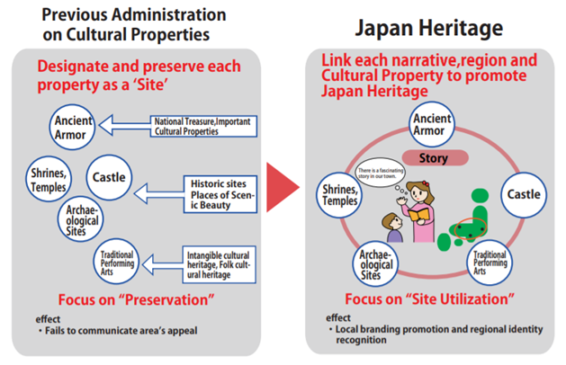
Fig. 2: The primary objectives of Japan Heritage (Source: Agency for Cultural Affairs of Japan)
    - The Case of France’s Heritage Policy

The French cultural heritage protection system began in 1789 when the French Revolutionary Army confiscated the assets of churches, the royal family and aristocrats and opened them to the public. The role of the state in the protection of French cultural heritage has been significant, because the policy of cultural heritage management was established to prevent the intentional destruction of works of art previously owned the monarchy and churches. Since the Act on Historic Monuments’ (Loi du 31 décembre 1913, sur les monuments historiques) was enacted in 1913, a full-fledged management of cultural heritage has been carried out. In 1959, the Ministry of Cultural Affairs was established (the first of its kind in the world), and more active cultural heritage policies were implemented by the ministry’s first minister, André Malraux. Poirrier has pointed out that Malraux law (Loi du 4 août 1962 complétant la législation sur la protection du patrimoine historique et esthétique de la France et tendant à faciliter la restauration immobilière), enacted in 1962, made major changes to France's cultural heritage policy in that it stipulates that the historic areas can be designated as ‘preserved sectors’ and regional planning should be established in consideration of this. Individual laws relating to cultural heritage have been integrated and maintained through the 2004 Cultural Heritage Act (Code du patrimoine). The definition of cultural heritage in this law states that ‘cultural heritage refers to, within the meaning of this code, properties and movable goods, belonging to public or private, which are of historic, artistic, archaeological, aesthetic, scientific or technical interest.’ Through the revision of the Act in 2016, the new provision has been inserted that states that cultural heritage also includes elements of the intangible cultural heritage, within the meaning of Article 2 of the ICH Convention. This means that the recognition of cultural heritage scope is expanding from tangible to intangible factors.
In addition, the French government, which implemented a centralised heritage management policy through the Ministry of Culture, has underscored the role of the local government in protecting and managing heritage with decentralised policy from 1983. Cultural heritage policies are being implemented through a link between central and local governments. Launched by the Ministry of Culture in 2000, ‘the cultural decentralisation protocols’ clarified the responsibilities of central and local governments by making local bodies key actors in activities such as conservation, restoration and exploitation of historical monuments. The decentralisation of power seems to have had a significant impact on the use of cultural heritage as a major resource for the regeneration and revitalisation of local economies. In particular, the France government has employed heritage sites as important tourist attractions. This is also illustrated in the report ‘54 suggestions for boosting tourism through our heritage sites’ by Martin Malvy, the former minister of budgets in 2017. The report has five main focuses: building governance with various stakeholders, a structural approach to meet tourists’ requirements, training for young people, digitalisation, and promotion of French heritage sites.
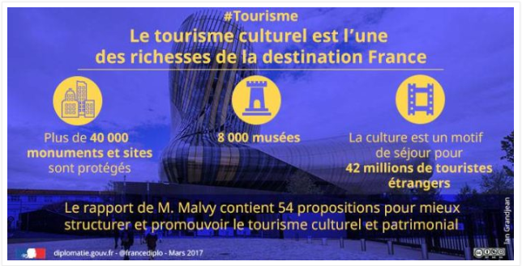
Fig. 3: Malvy report: Relying on French Heritage to Boost Tourism (Source: France Diplomacy)
As such, it can be seen that the cultural heritage is regarded in France as a significant resource to be protected and actively used for the culture and tourism industry. Heritage tourism policies that raise awareness and understanding of cultural heritage among visitors have implications for creating new audiences and informing future generations of the importance and value of heritage.

    - The Case of the UK’s Heritage Policy

The UK's heritage sectors share its roles and responsibilities with various institutions, including the Department for Digital, Culture, Media and Sport (DCMS), Historic England, English Heritage, the National Trust, and the Heritage Lottery Fund. Among them, the DCMS, which has a number of sponsored bodies, has been criticised for adopting a limited and expert-centred approach to public policy. As Smith pointed out in discussions on the AHD, official heritage authorities have only involved the state and professionals as policy participants to protect the values inherent in tangible buildings, objects and places. Waterton and Smith have argued that DCMS’s efforts to streamline the heritage management process, to strengthen social inclusion and involvement and support sustainable communities have been largely rhetorical, despite being useful attempts.
However, the UK's heritage sector seems to be continuing to undergo a shift in heritage management to a value-based approach through discussions concerning public value. Clark has argued that value-based management can be a rational process involving wider society in decision-making as opposed to expert-centred management. As an institution that drives a value-based change, the HLF has implemented a wide range of financial support. Established in 1994 to fund heritage projects, the HLF has played a crucial role in not only allowing the term ‘heritage’ to resonate in everyday life, but also incorporating the significance of public and community value into heritage management. On its website, the HLF lists a wide range of areas included in ‘what we fund’, from tangible materials such as historic buildings, monuments, and historical environments to intangible heritage including oral history and cultural traditions. Concerning the HLF’s work on financial support, Clark has discussed two major critical aspects. One is that the fund has put public's participation in heritage at its core. The fund covers programmes, events and activities that focus on public access and inclusion, as well as repairs and conservation. Additionally, a mandatory outcome of heritage projects funded by the HLF is that ‘a wide range of people will be involved in heritage’, further clarifying the fund’s aim. Another aspect is that the fund has broadened the horizon for heritage value by designing application processes for demonstrating the significance of heritage directly to applicants including communities. These heritage projects can change heritage management practices, which emphasise the importance of historical, aesthetic and archaeological values, to make them reflect community and public values. Through this, the heritage values that excluded the public can be viewed in a balanced manner. They can also positively affect the sustainable heritage management in the long term by drawing social, economic and environmental benefits from heritage resources.

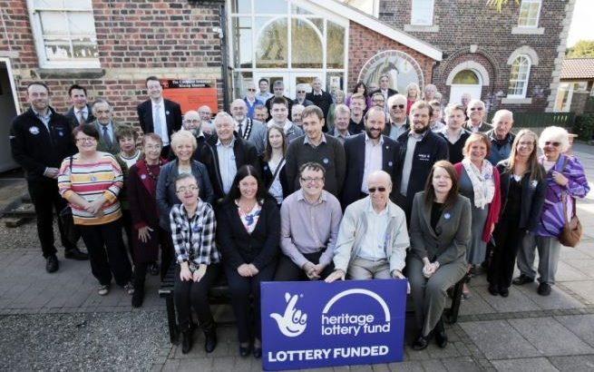
Fig. 4: the HLF project, ‘East Cleveland’s Industrial Heartland’ memorial photo, 2018(Source: East Cleveland Industrial Heartland Website)
  - Understanding Governance in the Heritage sector

    - A Definition of Governance

Governance is a concept that contrasts with government. Where government is a state-led traditional bureaucracy paradigm, governance refers to a network of policy actors acting through voluntary participation and cooperation. Governance has emerged as a concern in the transition from a government-centred paradigm to democratisation and decentralism across various fields, including politics, administration and culture. A variety of academic concepts of governance have been discussed by researchers since the late 1990s.
Kooiman has defined governance as a heterarchy or a network under the concept of New Public Management. This framing places governance as flexible organisation with autonomous cooperation based on interdependence between various actors. Stoker has referred to governance as a collaborative form of coordination that emerges from the blurred boundaries between the government-centred public sector and private organisations. He has also emphasised mutual cooperation partnerships between actors in the state, market and civil society. Additionally, Pierre and Peter have defined the concept of governance as a social governance system in which various stakeholders decide and enforce policies through consultation and consensus processes as independent participants, away from government-led control and management in policymaking.
This common concept of governance presented by several researchers can be understood to focus on the process in which actors coordinate and cooperate to achieve common goals. More specifically, governance is generally addressed in the areas of discussion related to the solution of social problems, the role of government and social operating systems. Governance is also presented as a concept that means something ‘new’ for cooperation and reform by breaking away from traditional concepts such as governing by state and government in various academic fields such as administration, politics, and sociology. Based on prior research, I will define the broad concept of governance as a decision-making process and an organic collaboration structure that various stakeholders make through mutual coordination and cooperation to achieve common goals.

    - Background of the emergence of Governance

A more precise understanding of the concept of governance characterised by multidimensionality and complexity requires an analysis of the background and changing processes of governance. Governance has been a part of the UK's policy-making system since it began to be discussed in earnest on a theoretical level by British scholars in the early 1980s, and later spread to other Organisation for Economic Co-operation and Development (OECD) countries.
In analysing the six uses of governance, Rhodes has argued that globalisation, disclosure of information and the spread of liberal democracy have triggered the emergence of governance. Pierre and Peters have analysed three factors as the main background of governance: the growth of intense demands for the private sector to engage in public policy; the emergence of New Public Management, an administrative approach developed to overcome traditional bureaucracy and implement small governments; and the increase in formal participation of groups and individuals in policy processes to ensure the successful implementation of policies. They have insisted that the role and status of the nation-state are being reduced as the functions of government move up to transnational levels, such as the EU and the World bank, move down to regional and local levels and move out to civil society and NGOs. Leach and Percy-Smith also have suggested that the significant differences between government and governance are as follows:

Table 1: From Government to Governance: the Shifting Focus
Old government | New governance
The state | The state and civil society
The public sector | Public, private and voluntary (or ‘third’) sectors
Institutions | Processes
Organisational structures | Policies, outputs, outcomes
‘Rowing’, providing | ‘Steering’, enabling
Commanding, controlling, directing | Leading, facilitating, collaborating, bargaining
Hierarchy and authority | Networks and partnerships
Source: Leach and Percy-Smith (2001:5)

In South Korea, various academic approaches to governance have been taken since the 1990s. Kim has claimed that public distrust of the nation-state’s incompetence and the growth of civil society, which failed to effectively address the ills of bureaucracy, have triggered discussions on governance in Korean society. Choi has discussed governance as emerging from efforts to seek alternative solutions to traditional administrative paradigms for facing environmental changes, such as the need for new strategies to cope with serious financial crises, globalisation, informational resources, and the spread of neo-liberalism. In other words, the background factors commonly claimed by researchers can be summarised as the crisis of government finances, environmental changes such as globalisation and localisation, government failures, and the need for compromise between government and market functions. The emergence of governance can be seen as a time when new actors, such as international organisations, regional and local governments, civic groups and markets, have begun to appear as the main players in solving the complex problems that have emerged beyond the government's ability to govern.

    - The Definition and Importance of Heritage Governance

In light of the definitions of the term ‘governance’ discussed in the previous section, heritage governance can be said to mean all the actions that constitute the various decision-making and management processes taking place in the heritage sector. Rather than directly using the term ‘heritage governance’ in the academic field, participation, involvement, and localism seem to be preferred terms for broad governance.
The emergence of heritage governance began with the trend toward the establishment of international organisations, such as UNESCO and the Council of Europe, to overcome various hardships that emerged in European countries after World War II. In particular, UNESCO, which plays the most pivotal role in the global cultural heritage sector, has placed the participation and cooperation of various stakeholders as essential elements of world heritage management in the Operational Guidelines for the Implementation of the World Heritage Convention since 1972.

Article 12
States Parties to the Convention are encouraged to adopt a human-rights based approach, and ensure gender-balanced participation of a wide variety of stakeholders and rights-holders, including site managers, local and regional governments, local communities, indigenous peoples, non-governmental organizations (NGOs) and other interested parties and partners in the identification, nomination, management and protection processes of World Heritage properties.
Since the 1970s, the emergence of complex heritage such as industrial heritage and cultural landscapes and the expansion of heritage scope, including into the concept of intangible cultural heritage, have made the close relationship between human beings and cultural heritage the core of the discussion. In this process, the authority and expert-centred heritage management system, which excluded local government and communities, was found to have limitations in sustainable heritage management. Since then, through various discussions surrounding world heritage, amateur skills and volunteer participation, long-term vision and planning, partnership and bottom-up approaches have become significant elements of sustainable heritage management. Many organisations in the field of heritage tend to regard participatory governance as a model of good governance. The participatory governance model generally considers active participation in the decision-making process of civil society as a legitimate and effective way of managing and preserving cultural heritage. The critical factors of heritage governance from these literature reviews are ‘participation’, ‘cooperation’ and ‘trust’. Heritage governance can be positively evaluated in that it is an effort at the democratisation and decentralisation of power by linking the public sector, where government and experts have played a major role, with private sector and civic groups including local people and heritage owners. However, heritage governance is not completed by the inclusion of several actors on the surface, other mechanisms are needed to ensure that they perform their respective roles well in order to promote their intended goals and effectiveness. Therefore, in this paper, I would like to draw up the measures for successful heritage governance through an analysis of heritage utilisation projects case studies in South Korea.

Chapter 3

CASE STUDY

3.1. Case Study 1: Heritage Night Project in Seongbuk

3.1.1. Description of the Project

The Heritage Night is a project supported by the CHA, for funding local councils’ applications for heritage tourism, which was launched in 2016. The aim of the project is to attract locals and tourists to heritage and make them feel the historical and aesthetic values of local heritage sites. In order to achieve this aim, local governments and NGOs open heritage sites until late at night and provide events with which participants can have a pleasant experience of local heritage. A national budget of about 5 billion Korean Won (about 330 million GBP) per year is allocated for this project and each local project is carried out two to four times a year.
Seongbuk District council started the Heritage Night Project in 2017. This area has outstanding natural scenery along the main ridge of Bukhansan Mountain and heritage formed during Korea’s modern era (late 19th‒mid-20th centuries) is located throughout the villages, creating a unique urban landscape. After liberation from Japanese colonial rule, numerous historic buildings and gardens in Seongbuk were designated national heritage properties. Since the 1990s, local heritage sites have been newly recognised as cultural resources based on the efforts and participation of the local authority, civic groups, and residents.
The core heritage resources for the project include the Seoul City Wall (Historic Site No. 10), Han Yong-un’s Simujang House (Historic Site No. 550), and Choe Sun-u’s House (National Registered Cultural Heritage No. 268). The 18.6 km Wall was built by King Taejo, the first king of the Joseon dynasty (1396‒1910), after moving the capital from Gaesung to Seoul. It has been listed on the UNESCO World Heritage Tentative Lists since 2012, because of its unique architectural style and preservation status. As such, the heritage value has been recognised at the international level, but at the same time, the value on a local level is very high, as it much beloved among local people. Simujang House is an old building in which Han Yong-un, one of Korea's most important independence fighters, lived until his death in 1944. Han Yong-un, a Buddhist monk and poet, led several independence movements in Korea, and his poems are influential enough to be taught to students in regular education curriculum.
The Seongbuk Heritage Night steering group has developed various programmes so that many people can enjoy the heritage of Seongbuk and enjoy its values. The programme proceeds as follows:
• Night opening until 11 p.m. of heritage sites and cultural facilities* including museums, free admission.
* Seongbuk Museum of Art, Seongbuk Seonjam Museum, Korean Stone Museum, Korea Furniture Museum
• Heritage guided Tour: providing visitors with information and interpretation of heritage and local history.
• Street Cultural Performance: Intangible cultural heritage performances, creative plays and musicals regarding Seongbuk history and traditions.
• Providing discounts and additional services at local shops.
For the success of the project, staff focused on consultation with various organisations and volunteer groups. As a result, the project was carried out in cooperation with eight cultural facilities, local resident communities and volunteer centres. The project also played a role in involving local people who were not interested in or even aware of the value of local heritage. In addition, it has been an opportunity for training local cultural heritage workers. The members participating in the project stated that they were able to acquire the skills of collaboration with heritage organisations as well as learn the importance of attracting audiences into heritage projects through the process of planning and preparing this project.

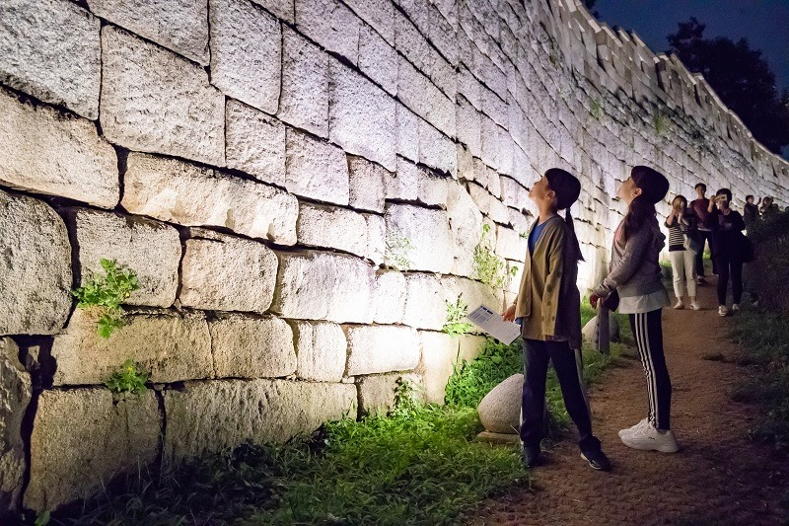
Fig. 5: Children who participate in Heritage Night and look around the Seoul City Wall, 2018(Source: the website of Heritage Night Project)

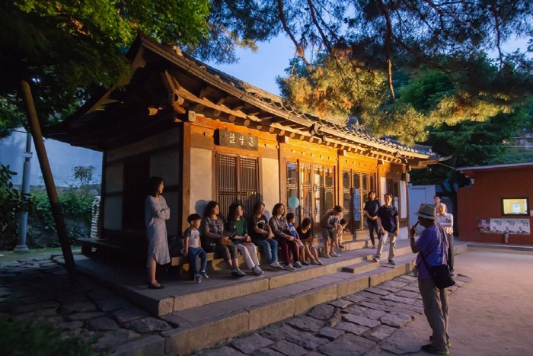
Fig. 6: Heritage Night guided tour with volunteers at Simujang House, 2018(Source: the website of Heritage Night Project)
3.1.2. The Governance Structure and Roles of Actors in the project

The group of actors involved in implementing this project is complex and diverse. Based on the interview with the project manager, I will analyse the roles of each project actor as shown in the table.
Actors for the project | The Roles of the Actors
Seongbuk  Cultural Centre | - Project Planning and Implementation  - Building and maintaining governance  - Promotion and support of information sharing and mutual discussions on the project delivery
Seongbuk district council  (local government) | - Local project budget support  - Administrative support (Road control, venue hire, etc)  - Establishing and emergency action plan for safety
The CHA (central government) | - Local project budget support and project evaluation  - Workshops for networking among participants
Professionals | - Consultation on the project plan  - Monitoring and Feedback
Cultural facilities  -museums, galleries | - Open at night  - Planning and implementing heritage-related performances and events in the facility
- Local People  - Culture and Art organisations  - University Clubs | - Project discussion with idea proposals  - participation in skills workshops, discussions as volunteers
Table 2. The roles of each actor for the project

The Seongbuk Heritage Night Project organisation is part of the Seongbuk Cultural Centre but there have also been wide-ranging partnerships. Administrative and financial support are provided by the central government, local government and professionals. Civic consultation bodies, such as cultural facilities, local people, and university clubs, also engage in the project as consultants at the level of project development and volunteers for delivery.
The Seongbuk Cultural Centre, the main body of the project, was established in 1996 as a cultural institution encompassing the protection and promotion of local culture and history. In 2017, the centre worked closely with Seongbuk local government, establishing and operating the Heritage Night partnership. The centre is in charge of planning and implementation of the project and supports the project by collecting ideas or requests from participants. In particular, the project members focus on maintaining the good relationship by forming a cooperative network with local cultural facilities, culture and arts organisations, and community residents. The support bodies are largely composed of administrative agencies (the CHA, Culture and Sports Division in Seongbuk district council) and experts (Korean Culture and Tourism Institute, the academy of Korean studies and so on). The project budget, which totals approximately 1.31 million GBP, is paid by the CHA and the local government by 50% of the total project cost. The Seongbuk district council provides continuous consultation and financial support for various Seongbuk Cultural Centre programmes to preserve the unique culture and heritage of the region as well as to expand exchanges with local people. Based on such strong public-private governance, the local government actively supports infrastructure for the project such as road control for the walking tour programme and venue hire for the opening event. Experts usually include historians and tourism experts. They play a role in providing effective direction and feedback so that the project can create new audiences for local heritages. They mainly served as assistants to help participants play their roles well through advice and consultation.
As consultants and volunteers for the project, private sector groups such as cultural facilities, community groups, culture and arts organisations and university student clubs also participate. They energise the project by providing fresh ideas as partners in planning and operating the program. The project manager referred to the ‘Seongbuk Beautiful People Community Cooperative’ as the most prominent participant group. He said, ‘Our centre, which focused on the need and importance of local’s participation from the first stage of the project, formed the cooperative network for residents to participate. Because the Community Cooperative is composed of residents who know well the place, we planned and designed a guided tour programme with the members of Cooperative. As a result, the programme had the highest score from the satisfaction survey among the various programmes.’ As such, the Seongbuk Cultural Centre has built a strong partnership and engaged with actors to the area where heritage-based governance has not yet been established.
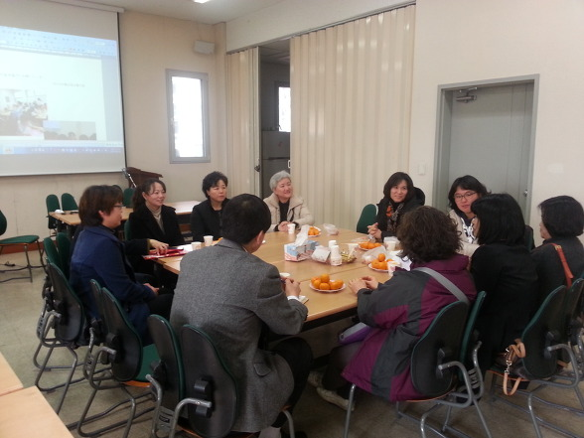 | 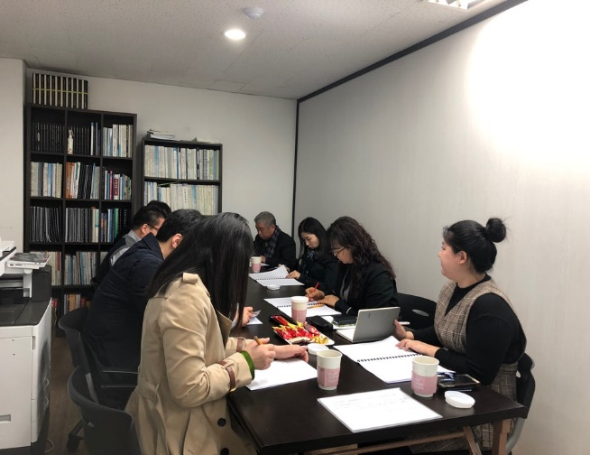
Fig. 7: Community member meeting(left) and Public-Private workshop(right) for the Heritage Night at Seongbuk Cultural Centre, 2018 (Source: Seongbuk Cultural Centre website)

3.2. Case Study 2: Wolbong Seowon Heritage Project

    - The Description of the Project

Wolbong Seowon is a local listed building located in Gwangsan District, Gwangju Metropolitan City, South Korea. Seowons ‒ Korean Neo-Confucian Academies ‒ were established throughout the country with the aims of education, veneration and interaction among scholars between the mid-16th and late-19th centuries. During the 16th and 17th centuries, Seowons served as an educational institution leading the Joseon Dynasty society, but by the late 18th century, they focused more on veneration functions for enshrined scholars than on educational functions. The Seowon was inscribed on the UNESCO World Heritage List on the basis of criterion(ⅲ); to bear a unique or at least exceptional testimony to a cultural tradition or to civilization which is living or which has disappeared.
Wolbong Seowon began its history in 1578 when the local intellectual groups of Jeolla Province built a shrine to honour the renowned neo-Confucian scholar, Gobong Ki daeseung (1527-1572). The Seowon, which had served as a place for learning and community interaction, was closed in 1868 due to a state-level measure to abolish Seowons for modernisation. In 1938, Ki’s family and descendants led the restoration of Wolbong Seowon, and in 1991, the current form of the site was established through restoration and reconstruction of the damaged or disappeared buildings.
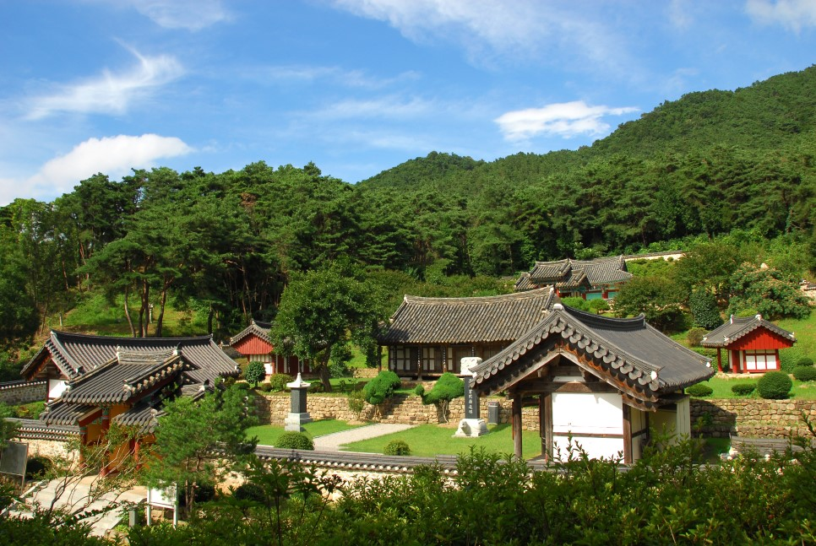
Fig. 8: Panoramic view of Wolbong Seowon, 2019 (Source: Wolbong Seowon Website)
The local government, Gwangsan District, started the ‘Cultural Heritage Revitalising Project’ in 2008 to bring the heritage value and a sense of place to the local people and encourage them to be involved in cultural heritage. The Gwangwan district council planned the project to recreate heritage building as a network place for local people and as historical learning spaces. As a result, the project was awarded the CHA's Excellent Heritage Project Award for three consecutive years between 2014‒2016 and was also promoted as the example of best practice. The Seowon carries out a total of seven programmes over a year as follows.

Name of Programme | Main Audience | Contents
A day of Ki dae-seung | Students | Experience the daily life of a classical scholar with a special costume
Kid Philosopher Imagination School | Children aged 4‒6 | Play-learning regarding humanities for children
Kitchen of philosopher | Disabled and vulnerable people | Community kitchen activity with  special recipe from the region
Salon de Wolbong | Local people | Cultural performance, discussion place
Wolbong Romance | Tourists | Audience-participating play based on episodes related to Gobong Scholar
Unique Workshop, ‘Like Gobong, Next Gobong’ | Public | Storytelling Concert, discussion with participants
Scholar’s heritage exchange programme | Local people | Cultural exchange programme with other seowons
Table 3. Specific Programmes of Wolbong Seowon Heritage Project in 2019

Programmes are designed to be accessible to people of all ages, offering experiences and educational activities. In particular, efficient methods are taken to achieve the goals of the project by clearly identifying the targets, including local students, disabled people, tourists, and ordinary citizens. In 2016, the new programme ‘Nervesil Recipe of Seowon Village’ was evaluated as the most successful programme through a self-evaluation. For the programme, villagers prepared meals using local food and sold them to tourists to earn profits. Such efforts have led not only to the diversification of the heritage audiences including children, teenagers and foreigners, but also to a quantitative outcome of about 3,500 participants in 2019. The local government and other cooperation organisations are continuously delivering the heritage project by consolidating the value of cultural heritage in 2020.
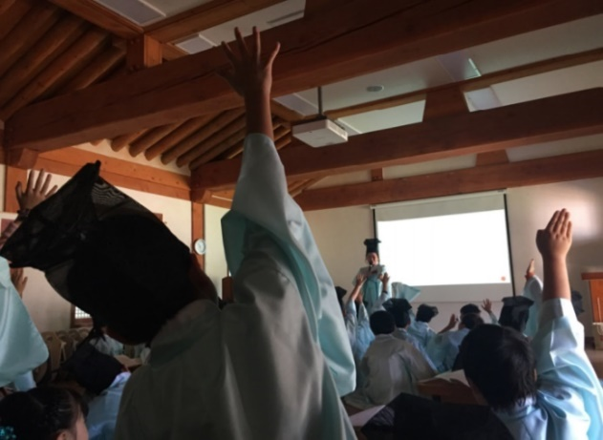 | 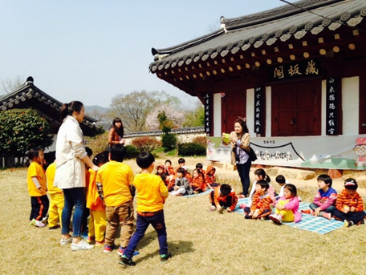
Fig. 9: Wolbong Seowon programmes for children and young students (Source: Wolbong Seowon website)

    - The Governance Structure and Roles of Actors in the Project

The Wolbong Seowon Heritage project is carried out by establishing partnerships with local government, owners, local cultural organisations, and villagers. Since the local government hire the project manager as a non-permanent public officer to operate the overall stages of planning, delivery and evaluation of the project, responsibility and authority for the process are clearly given to the project manager. The project manager plays a significant role as the director of the project and as a medium for connecting various partners, including central government, local council and private organisations. The local government noted the fact that Wolbong Seowon, which has important value in the region, was regarded only as a low-profile and outdated old building by villagers and recognised the need for a project to inform people of the story of the Seowon building and its intangible characteristics. The Gwangsan district council has provided financial and administrative support for the project. Each year, about 50 million Korea Won (34,000 GBP) is granted to the project, and the Cultural Heritage Promotion Division, newly organised within the council in 2017, systematically supports the heritage projects. One of the most important actors in the project was owners of Wolbong Seowon. This is because it would be impossible to implement the various programmes that take place inside the heritage area without the opening of Seowon buildings and facilities. Therefore, the project manager held several meetings with the Seowon owners and villagers to persuade them of the significance of the heritage buildings within the region and discuss launching the heritage project so that the younger generation could come, learn, and enjoy the Seowon. As a result, the owners not only open the space but also actively participate in programmes such as education for local students.
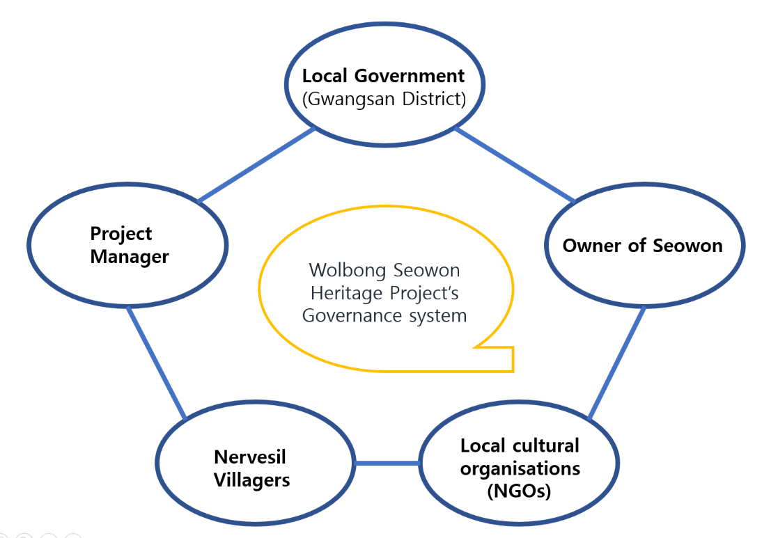
Table 4. Wolbong Seowon Heritage Project’s governance structure

Additionally, private cultural organisations in the region participate as key actors in planning and delivering detailed programmes. A total of three organisations ‒ ‘Education and Culture Community, Gyeol’, ‘Culture project design company, Rau’, ‘Imagination creation centre, Spring’ ‒ are partnering. These organisations mainly work with young planners in their 20s and are responsible for programme planning and practical operations for programmes helping young people to derive contemporary functions and specific meanings form Wolbong Seowon. In particular, their participation greatly affected the development of novel ideas and programmes that could improve people's perception of Seowon as an old and inaccessible space for the public.
The participants who stand out in this project are villagers. The Seowon is located on the outskirts of Gwangju Metropolitan City. The village, which has been formed around Seowon, is called Nervesil Village, which was previously underdeveloped and inhabited mainly by elderly people. In this context, the project manager and the council discussed how residents could participate in the heritage project while consulting with the villagers. As a result, the ‘Nervesil Recipe of Seowon village’ programme was operated to cook and sell meals with agricultural products raised by the villagers, taking into account the lack of dining facilities in Seowon. This is meaningful in that it not only utilised a heritage building but also sought a win-win solution for local people and heritage by encouraging the participation of villagers and creating economic benefits.
+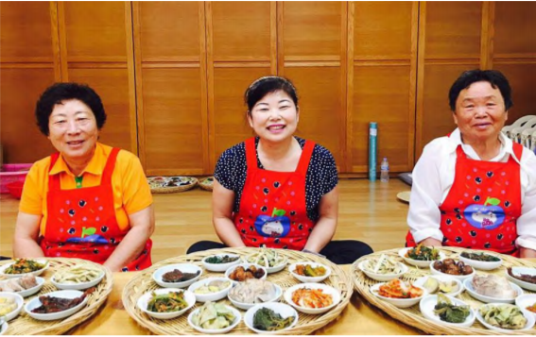
Fig. 10: Nervesil Villagers with the meals they cooked, 2016, (Source: Wolbong Seowon website)

The project manager emphasised that the Wolbong Seowon project is based on governance with equality and autonomy for actors. The manager argued that in a heritage project involving multiples actors, if some participants take the lead or force in a particular direction, the project's outcomes are difficult to derive. In summary, the process of participants sharing project objectives and directions, collecting ideas through workshops and meetings and then realizing goals step by step is important in heritage project governance.

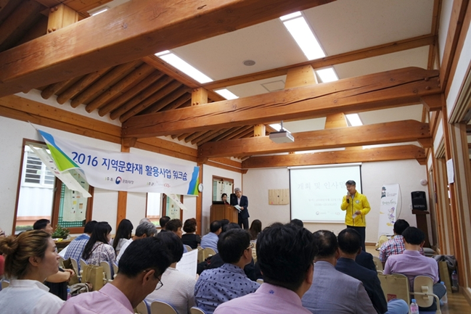
Fig. 11: The workshop among participants at Wolbong Seowon, 2016 (Source: Wolbong Seowon website)
  - Interviews with Heritage Project Managers

Combining the above two examples, the main actors in the heritage project can be divided into three groups:
• Public sector: central government, local government
• Private sector: experts and cultural organisations, NGOs
• Civil society: local community, villagers, students, local businesses
This section explores the governance limitations and implications of my two case study projects – Heritage Night Project in Seongbuk, Wolbong Seowon Heritage Project. Despite the various opinions presented by project managers in the interview, the main themes related to governance that interviewees emphasised for the successful implementation of South Korea's heritage projects can be summarised into four main themes: network development, trust and cooperation, participation and sustainability. In this section, interview data will be analysed according to each of the four themes.

1) Network development
'Networking' has been shown to be a significant factor in the governance of heritage projects. Networking here means the exchange of information and ideas with common goals and interests by individual groups operating with different purposes. In general, project managers attract several partner members as a network hub and establish governance by playing a key role in mutual communication and coordination. It was a loose-type network consisting of only government and cultural organisations in the early stages of the project, but it has developed into a more diversified and advanced network through the participation of various actors.

Gwangsan council hires a professional project manager as a temporary public officer. The manager is responsible for the strategic planning, delivery, and promotion of the cultural heritage project. Ordinary public officers are rotated for one to two years, so the sustainability of the project and the long-term prospect of cooperation with the organisations are inevitably reduced. The project manager brings together organisations and people from different sectors to build networks at the beginning. Each actor can share ideas and discuss through the regular meetings and workshops. By creating opportunities for participation, such as forums on local heritage, we could see that the partnership has been strengthened and participants' pride, responsibility, and affection for cultural heritage have increased. (interviewee 1)

I think that the heritage project can be achieved well when the central government's budget support, the local government's regional preservation and promotion heritage plans, and the participation of various heritage-related organisations and local residents are combined. In this respect, the project is not just a task, but an organism. Even if citizens are passionate about heritage and willing to participate, it is hard to make that a reality without a sufficient budget and human resources. On the contrary, I think state-led projects have limitations in reflecting the specificity of the region and in drawing voluntary participation from residents. Therefore, building a public-private-society partnership is essential for the heritage project. (interviewee 2)
In particular, the development of network centred on heritage requires a process of enhancing steady interest and understanding of heritage through continuous exchanges with cultural facilities, schools and villagers in the region. Because the perception that heritage is a professional field, with conservation and restoration at its core, is prevalent throughout society, continuous cooperation and mutual conversation are necessary to shift conventional awareness in connection with other fields such as culture, tourism and education.

Building a partnership with multiple organisations in a short period of time for a project can be a daunting task. Therefore, I think it is very important to continuously interact with people focusing on heritage. Our organisation, Seongbuk Cultural Center, has been very passionate about the exchange with local cultural facilities and communities. We have also worked hard to interact with many cultural artists and educational institutions in the region, as well as historical and heritage facilities and experts. Seongbuk Traditional Music Association, Seongbuk Art Association, Seongbuk Play Association, Seongbuk Merchants Association are all our partners. (Interviewee 2)

2) Trust and Cooperation
Sharing information related to the decision-making process and results of the project with participants is very important for enhancing the reliability of the project and fostering cooperation. Specifically, being fully informed about which applications are selected, how the budget is distributed and who can participate in the entire process is significant, because it serves to demonstrate the fairness of the decision-making process and to increase confidence in the project. Equity and transparency should be maintained in the procedures included in the project, and a system of checks and balances is needed among participants to resolve conflicts that might emerge in the project's implementation.
The central government selects which projects to support among the applications submitted by the local government, and the local government selects the organisation to carry out the projects among several cultural heritage organisations. After all, given that the project delivery is a constant evaluation and selection process, I think it’s important to go through the procedures so that everyone can understand and the results can be transparent. (interviewee 2)
Some partner organisations are not very interested in promoting and enhancing heritage value but may focus only on earning revenue through the grant from the government. Since this moral hazard can often be seen in the process of heritage projects, it is something to be very wary of. Therefore, we usually try to increase transparency in the project by involving three or more organisations and villagers to monitor and check each other. (interviewee 1)
At the initial stage of heritage project development, it is important to share and listen to the opinions of local people on why the heritage project should be carried out, along with understanding the heritage itself. This step is expected to be a process of finding out the residents’ perceptions and understandings of heritage, while at the same time instilling awareness of the project. In the process, those who become aware of the necessity and importance of the heritage project can be motivated to participate more actively in the future and may show a strong willingness to cooperate.
As in any region, locals don't like to be violated by an increased number of visitors when a new programme launches within the area. So, it is very difficult to convince residents to work on the project together. In our case, some of the locals were negative about the Heritage Night project because the area would be noisy until late at night and the streets would be dirty with rubbish. However, as a project manager, I have felt that they are able to trust our organisation, because I actively listen to their opinions and lead discussions together. It may take a long time to go through discussions and gather ideas, but ultimately, beyond the project, it could spark participants' understanding and interest in heritage. (interviewee 2)

3) Participation
Enabling voluntary participation, allowing participants to freely express their opinions, and reflecting their ideas in the actual project are crucial intangible outcomes of heritage projects. Indeed, the need and significance of participation in the heritage field has steadily increased, but there has also been criticism that the participation remains rhetorical. In order to trigger genuine participation in heritage projects, participation methods such as workshops and free meetings, which allow actors to develop the project together from the initial planning stage, are of considerable importance. It is also necessary to build new audiences for heritage, including young people who used to be passive and marginalised in heritage activities.
During the project implementation, major participants try to gather together to share opinions and draw conclusions whenever an issue occurs, not only at regular meetings. Considering the advantages of Seongbuk district, where the community network is active, we continue to discuss issues related to the heritage project. (interviewee 2)
We often hold the workshops among project participants. Usually, there are four to five workshops over a month. The workshop is attended by all groups necessary for planning, delivering and promoting the project, including owners, villagers, the Gwangju Office of Education, Gwangju Tourism Association, Honam University Confucius Academy, and the Gwangju Metropolitan City Travel Agency. Through these workshops, we are able to improve the accessibility for visitors to Wolbong Seowon by allowing city buses to pass through the Seowon. We also discussed the placement of heritage guides and the creation of various hands-on events for tourists. (interviewee 1)
For private sector participation, the provision of information and project promotion through online and offline methods seems to play a significant role. In particular, it is necessary to diversify promotional methods to suit the target, and it can be useful to use different methods depending on whether they are targeting students familiar with social media or older people who are not.
The villagers around Wolbong Seowon are mainly elderly people who are not familiar with the Internet. Therefore, in order to inform these people of the project and encourage them to participate, it was useful to advertise in local newspapers or on local TV broadcasts and put posters up in the local cafés and restaurants. However, in order to appeal to the younger generation who actively use social media, we are trying to promote the project in a more less formal and more interesting manner in the form of cartoons and caricatures through Facebook and Instagram. In addition, in case of programmes that require pre-booking, we increase participation by distributing programme brochures and holding the project presentation meetings in connection with local schools. (Interviewee 1)
Ordinary people without expertise in heritage projects only appear to be ostensibly involved, but it is difficult to actually reflect or include their opinions in depth. The reason for this is that participants become passive, because they think they do not have expertise and because the steering group, which is centred on the project manager, treats non-expert opinions as insignificant. These problems are likely to be solved to some extent through a series of training activities and the accumulation of experience from taking part in the process of the project.

Community participation is a good term, but it poses difficulties in real life. One villager who participated in the workshop asked, ‘I don’t know even what heritage is, what advice can I give to the experts?’ (interviewee 1)
The local people working in volunteer groups and cultural and artistic organisations in the area are likely to present various perspectives and new ideas on the programmes regarding heritage interpretation. Members of the Seongbuk Theater Association suggested creating a new play about historic buildings in Seongbuk to easily convey the value of heritage to the audiences. For volunteer recruiting, we have linked up with the student centres of the universities in Seongbuk district and tried to attract many young people by promoting the project via social media. (interviewee 2)
4) Sustainability

The sustainability of the heritage project is possible when an attractive project is created that allows people to feel the value of heritage without losing its authenticity. Due to the nature of the heritage project, which attracts many visitors, it is desirable for the heritage project to be considered in conjunction with the local heritage management and preservation plan in a broad framework to prevent damage to the heritage sites. Preservation, restoration, utilisation, and enhancement of value surrounding heritage can have a positive effect as a circular process, operating follows:
I think heritage projects such as education and tourism can only be achieved together if the heritage itself is well maintained and preserved. The Gwangsan District council has prepared a ‘Cultural Heritage Area Conservation Plan’ including the restoration of the Wolbong Seowon and the improvement of the surrounding environment. At the same time, the council also considered the development of programmes to spread the value of cultural heritage under the plan. (interviewee 1)

I think preserving and utilising heritage is a complementary relationship. Well-preserved heritage holds a wide range of value for a long time, and when utilisation programmes are developed, people become more aware of the significance and value of the heritage. This could eventually lead to greater conservation and management of the cultural heritage by strengthening financial and staff input. I think this virtuous cycle structure makes the heritage ecosystem healthier and creates a sustainable heritage management system. (interviewee 2)
The heritage project requires a stable budget, because it costs vary and include significant expenditures such as labour costs and equipment rental costs. Project managers emphasised that the government is an important actor in funding and stressed the need for an appropriate level of support from the government until the heritage project is established and self-sustaining. At the same time, however, they agreed on the need to form a revenue generation structure through donations, participation fees and the sale of goods from audiences and visitors created by the project in the long term.
For now, the project is heavily dependent on government (both central and local) budget support. We are trying to make a profit in the form of receiving some participation fees from visitors, but so far, paid programmes low participation rates. Given the fact that the transition from government-led heritage management to a heritage project development with the participation of a local community is in the beginning stages, I think the government's support has a significant impact on the success or failure of the project. (interviewee 1)

I think there could be various small-scale, community-led heritage projects in the future. These projects will have to be considered for steady revenue generation through goods sales and voluntary donations from participants. It is no exaggeration to say that the continuity of the project depends on the financial aspect. (interviewee 2)
In addition, proper evaluation and feedback should be made after the project is terminated, along with setting mid- and long-term goals, so that the project’s aims can continue to be met. This is seen as a significant method of preventing heritage projects from becoming mere leisure or entertainment events that neglect to share the meaning and value of heritage itself. As a heritage-mediated project, an analysis will be needed in the process of running the project to determine whether the heritage is well-presented and helps people to understand its aims and whether the programmes are being provided in a way that is useful to the target audiences.
I think it is important for project managers to set long-term aims and create a project that can connect places, heritage, and people organically. In particular, the project's performance will be better if the target group is subdivided and the programmes are organised according to the exact target. (interviewee 1)

I'm working on a project every year, and I think the assessment and feedback on the project are very important. Every project goes through the planning, delivery, and evaluation phases. For heritage projects, especially, qualitative assessment such as satisfaction survey of participants can be effective. I think the project will continue to develop when the evaluation results are thoroughly analysed and this will improve the planning and operation of the next project. (interviewee 2)

Chapter 4

FINDINGS

According to the case study analysis, heritage projects in South Korea have the following features.
∙ Central and local governments support the project budget and evaluate the result of the project.
∙ When local governments create value-enhancing heritage projects alongside regional heritage conservation and management plans, the projects are maintained and developed actively.
∙ Several private cultural organisations and NGOs have planned and delivered various programmes with cultural heritage as the key resource. Heritage Night in Seongbuk included programmes such as guide tours, plays or performances for tourism, and Wolbong Seowon programmes included education and hands-on learning programmes for local residents and students.
∙ Local people and communities are found to be participating in each process, but it is difficult to say that participation is embedded in the project.
Based on these characteristics, this sector will discuss what factors are needed to further develop heritage projects by establishing the governance of various participants.
• Clarify the Roles of Governance Participants
As discussed in previous chapters, cultural heritage develops in a broad sense, not just in an object or a building, but in a combination of intangible elements surrounding the materials. Additionally, a heritage project can achieve its aims and objectives when it is created with the participation of third sector actors such as local communities and volunteers, in addition to experts and governments who have been considered key actors in the authorised heritage management in the past. This is because heritage projects aim to strengthen the value and use of heritage in the socio-economic context by linking heritage and our society. The role of current project participants can be summarised as follows:
- The central government is responsible for budget support and project evaluation
- The local government is responsible for the repair and restoration of designated cultural heritage areas and buildings and supports heritage projects in terms of financial and administrative needs.
- NGOs plan and operate programmes for various purposes, such as education, tourism and training.
- Local people and community groups participate in the form of volunteers or small businesses.
Above all, the role of local governments should be strengthened to implement stable heritage projects. The local government is the main body for establishing a wide range of plans for heritage and the preservation of heritage. Therefore, it is also necessary to foster various organisations and local communities in the region under the overall heritage protection plan so that they can be engaged in the projects. In particular, if the purpose of the heritage project is to not only promote heritage values but also strengthen the social bonds to make a place more liveable and happier, the role of local governments will be more important. In addition, the more tourists that visit an area through heritage tourism projects, the more invigorating the hospitality industry, such as lodging and restaurants, will be, which can help the local economy. Given these socioeconomic effects, local governments should be the pivotal actors in heritage projects that can further promote and spread the value of heritage within their regions. At the same time, there is an important role in the governance of heritage projects for civil society sectors such as local communities and private heritage organisations. They are not so influential at the moment, but they can serve as a major mechanism in developing sustainable heritage governance. Currently, in the case of South Korea’s heritage projects, the central or local government takes the initiative in establishing governance and managing all the processes during the period when subsidies are paid, but the project's outcomes disappear after the support ends. This is also a chronic problem of many budgeted projects supported by the government. Therefore, in order for heritage projects to emerge newly and proceed even after the completion of the project, a community-led governance system must be in place within the project period. When building this governance framework, the cooperative partnership among participants will be significant.
• Building the Capacity of Participants and Strengthening Transparency
Heritage should not be a slogan that is far from reality but a subject that interacts and communicates with people in a local community. In this respect, heritage-led projects should be carried out with the public, and they should share in the judgment of. This is because the meaning and value provided by cultural heritage projects should be able to form a broad consensus among the public. As a result, in order to induce active participation of ordinary people, it is essential to implement a process for strengthening their capabilities so that they can become a principal actor. Capacity building programmes can motivate local people to cultivate a sense of participation and ownership and be interested in cultural heritage on their own. Such programmes can also serve as training exercises for teaching the average person ‒ who, as a lay person, may feel insufficient and awkward in participating in a heritage project ‒ the basic knowledge and know-how needed for understanding the project. In the evaluation report on the South Korea’s heritage projects in 2018, when participants were asked what they needed to develop the project and to induce participation, the largest number of people responded that training and learning activities concerning heritage and the project were the most necessary.
Interchange platforms for capacity building should be available in a variety of forms, including workshops, consultations, case studies, conferences, network parties, and so on. It could also be effective for experts to mentor or advise people who are not familiar with heritage projects. The capacity building can not only foster new workers in the heritage sector but also diversify heritage-related jobs, attracting a variety of roles. Indeed, the Wolbong Seowon project manager held several workshops as a means of developing the capacity of villagers, providing them with the opportunity to create programmes with which to share the heritage value with visitors, while allowing them to learn the historic and aesthetic values of the Seowon.
Efforts must also be made to enhance transparency in order to raise trust and produce cooperative spirit among actors. In governance, transparency can be secured to some extent through information sharing among participants. Since cultural heritage has the nature of a public good, it is reasonable for people to share information on the designation and management of the heritage. Similarly, the progress of a heritage project also needs to be made public to the extent that those interested are fully informed. The enhancement of transparency is closely related to the legitimacy of the project and provides a mechanism to smoothly overcoming conflicts by forming an emotional and cognitive homogeneity among the governance actors. In this regard, it is necessary to disclose information related to project selection and progress procedures and to discuss them with various participants. In particular, it would be desirable to make use of various methods, such as websites and social media, to improve the convenience and accessibility of information communication.

• Developmental Settlement of Evaluation-Feedback Structure for the Project Sustainability
In order for a project to continue to develop, evaluation and reflection conducted by project participants must be thoroughly carried out after the project is implemented. This is because the evaluation process allows the obtaining of feedback that can improve the quality of heritage projects. Cultural heritage has many different characteristics. In the case of historic buildings, they can be the theme of the projects around the various aspects of its historical value ‒ such as when and why it was built, what it has been used for over the years ‒ or its public value, such as how the locals perceive it and how it can be used in the future. Additionally, since the cultural landscape is characterised by residents living in the heritage area, heritage projects may help to enrich the lives of residents by generating profits through heritage tourism or events.
Therefore, heritage projects need to plan how they will be evaluated from the beginning, and the assessment results should be shared with all the participating members in order to discuss improvement measures. A heritage project can be evaluated in two ways: quantitative and qualitative assessments. Quantitative assessments can be made by quantifying how many visitors have come, how many programmes have been implemented, and how many jobs have been created. On the other hand, qualitative assessments can be conducted through surveys of participants and will look at whether the project has achieved the objectives expected of it, how much participants feel they have a better understanding of heritage, or what experience they have gained. Based on these assessments, a variety of heritage projects can be developed to improve the deficiencies shown in the previous project so that participants can be satisfied while revealing the characteristics and locality of the heritage well. Finally, the analysis of the results of the heritage project, including economic earnings and jobs created for local businesses, will further help spread the perception that heritage is an important resource with social and economic benefits.

Chapter 5

CONCLUSION

The key point of a heritage utilisation project is to ensure that cultural heritage has a positive impact on the lives of ordinary people, forms a wholesome culture and further contributes to social development. These projects not only help heritage establish a closer relationship with our daily lives but can also be an important medium for strengthening the preservation of heritage. Additionally, in order for these projects to function properly and produce the fruitful effect, all actors involved in the heritage utilisation activities, including the government, the private sector and civil society, must play their respective roles and build a cooperative partnership. Therefore, this study has analysed South Korea’s heritage project cases under the premise that governance should be built and operated in the implementation of projects and drawn implications for the development of future projects.
For this purpose, two Korean heritage projects were selected for the case study after reviewing the relevant theories and literatures concerning 'heritage' and 'governance'. Although these projects were started in earnest with government support, they have been highly satisfactory to the participants of the projects and were evaluated as examples of best practice in terms of their methods for encouraging the active participation of private sector and civic groups. Prior to examining these case studies, I analysed changes in the cultural heritage policies of some countries and defined heritage governance. In doing so, I tried to examine the changing trends of concepts and activities surrounding heritage in a global context and discuss the management policies of South Korea in more detail. Examining the heritage policies of Japan, France, and the UK, I determined that each government has been changing from a protection and preservation strategy to a comprehensive recognition of both tangible and intangible heritage and is in the process of transferring management authority from central government to local government. Various projects have been found to share the value and meaning of heritage via the means of tourism, education and even leisure in a way that is useful to local communities.
Data for the case studies was collected through project manager interviews, and the implications can be derived by analysing the actors’ roles and current states of the governance of the projects. According to the analysis, although the government, private organisations and civil society have all been involved in each project, there has been a difference in their importance. It turned out that factors such as partnership, trust and cooperation and participation and sustainability have important impacts on the smooth implementation of heritage governance. In order to build a partnership, a responsible and professional hub is needed, and steady interaction and understanding based around a pivotal actor has been essential. Trust and cooperation have been shown to be important, because they are intangible capital that not only promotes the participation of various actors but also sustains it.
The enhancement of transparency and information sharing are significant factors in building trust. Participation is considered the most important part of heritage governance, and in order not to include only rhetorical and sloppy participation, training and education to strengthen participants’ capabilities and the provision of sufficient information should be supported. Finally, for sustainable heritage projects, high-quality projects suitable for the characteristics of heritage and target audiences should be steadily developed through long-term goal setting, evaluation and feedback, along with securing financial support.
Although this paper focused on cases in Korea, it might be possible that the problems and improvement measures useful to South Korea’s heritage projects can lead to more universal implications, as heritage projects have been carried out in many countries. In particular, a heritage project is meaningful in that the outcome of the project can be spread to other areas, including society, culture and the economy, while also working to protect and preserve heritage itself. Heritage projects can contribute to attracting human and financial resources to the heritage field, because they raise people’s interest in heritage, awareness of its significance and the need to protect it. As a result, stronger and more effective conservation activities can be achieved. Additionally, participating in heritage activities gives local people a stronger sense of place, allowing them to feel more happiness and a greater sense of belonging. It can also create a structure where income is generated through heritage, making the lives of local people more prosperous. These benefits indicate that heritage does not stay in the past but has the value of having utility in the present.
To create these effects, some improvements have been presented in this paper. First, it is necessary to establish a clear role and decentralise authority among the actors involved in the heritage project. In South Korea’s current situation, where the central government with budget and expertise has relatively large authority over the community, top-down heritage projects are bound to be developed. Thus, within the government sector, various projects suitable for the specificity of the region can be implemented only when authority is shifted from central to local. In addition, more broadly, the effectiveness and sustainability of projects can be maintained for a long time when the role and accountability of the private sector and civil society are enhanced. Second, it is necessary to strengthen the capacity of participants and to be open and share information. The civil society represented by the community and locals may often feel a psychological distance from participation in heritage projects due to a lack of professional knowledge and related experience in heritage. In order for heritage projects to nurture future workers and attract a wide variety of people to the field, training and education programmes should be made available to participants and the general public. Furthermore, the process of disclosing and discussing the participation procedures, budget distribution and evaluation results may contribute to enhancing the legitimacy and reliability of a project. Finally, a follow-up structure should be established that reflects the appropriate level of assessment and feedback so that a project can be sustainable in the region. In the early stages of a project, lack of understanding and limited resources can make it difficult for participants to produce satisfactory outcomes. Therefore, it is important to establish a continuous evaluation system and steadily develop projects by reflecting on the results of the evaluations.

Bibliography

[Primary Source]

Barile, Sergio and Saviano, Marialuisa, ‘From the management of Cultural Heritage to the Governance of the Cultural Heritage System’, in Cultural Heritage and Value Creation, ed by G. Golinelli (Switzerland: Springer, 2015).

Cha, Mi-ok, et al., Building a Governance System for Regional Development in Korea (GyungKi: KRIHS, 2003).

Choi, Kyungeun, ‘Examples and Implications of Tourism Utilisation in Japanese Cultural Heritage’, Korea Tourism Policy, No. 77, 2019, pp. 116-121.

Choi, Kyungeun and Oh, Hoonsung, Measures to Vitalize the Use of Cultural Heritages to Boost Tourism (Seoul: Korea Culture & Tourism Institute, 2019).

Choi, Sung-Wook., ‘Research Trends of Governance in Korea: A Critique on the Conceptualization of Governance’, Journal of Governmental Studies, Vol. 10, No. 1, 2004, pp. 239-261.

Clark, Kate, ‘The Shift toward Values in UK Heritage Practice’, in Values in Heritage Management, ed by E. Avrami et al (Los Angeles: Getty Publications, 2019).

Clark, Kate, ‘Values-Based Heritage Management and the Heritage Lottery Fund in the UK’, The Journal of Preservation Technology, Vol. 45, No. 2, 2014, pp. 65-71.

Cortés-Vázquez, Jose, et al., ‘Heritage and Participatory Governance: An analysis of political strategies and social fractures in Spain’, Anthropology Today, Vol. 33, No. 1, 2017, pp. 15-18.
Cultural Heritage Administration, Guidebook on the utilisation of cultural heritage (Daejoen: CHA Press, 2007).

Cultural Heritage Administration, The Final Monitoring Report for the Heritage Night projects (Daejeon: CHA publication, 2018).

Cultural Heritage Administration, Yearbook of Cultural Heritage 2019 (Daejoen: CHA Press, 2019).

European Union, Participatory Governance of Cultural Heritage (Luxembourg: Publications office of the European Union, 2018).

Fairclough, Norman, ‘Critical Discourse Analysis’, in Discourse Studies: A Multidisciplinary Introduction, ed by Teun A. Van Dijk (London: SAGE Pulications Ltd, 2011).

Kakiuchi, Emiko, ‘Cultural Heritage Protection System in Japan: Current Issues and Prospects for the Future’, GDAŃSKIE STUDIA AZJI WSCHODNIEJ, Vol. 10, 2017, pp. 7-26.

Kim, Jung-Yul and Kim, Si-Yun, ‘Governance and Administrative State’, Korean Journal of Political Science, Vol.10, No. 3, 2003, pp. 23-44.

Kooiman, Jan, ‘Governance and Governability: Using Complexity, Dynamics and Diversity’, in Modern Governance: New Government-Society Interactions, ed by J. Kooiman (London: SAGE Publications, 1993).

Kwon, Cherry, ‘Legal Aspects of Cultural Heritage: the French Approach’, The Journal of European Constitution, No. 30, 2019, pp. 271-307.

Landorf, Chris, ‘A Framework for Sustainable Heritage Management: A Study of UK Industrial Heritage Sites’, International Journal of Heritage Studies, Vol. 15, No. 6, 2009, pp.494-510.

Leach, Robert and Percy-Smith, Janie, Local Governance in Britain (New York: Palgrave, 2001).

Lim, Jun Sung, ‘Gobong Kidaeseung ruins and artifacts of cultural content Wolbong Seowon Utilise’, Studies in Confucianism, Vol. 27, 2012, pp. 91-132.

Ministry of Culture, Sports and Tourism, A study on the Current Status of Humanities Programmes in the Public Sector and the Improvement Plan (Seoul: Korea Culture & Tourism Institute, 2018).

Pai, Hyung Il, Heritage Management in Korean and Japan: The Politics of Antiquity and Identity (Seattle and London: University of Washington Press, 2013).

Phillippe, Poirrier, Heritage and Cultural Policy in France under the Fifth Republic, International Journal of Cultural Policy, Vol. 9, No. 2, 2003, pp. 215-225.

Pierre, Jon and Peters, Guy, Governance, Politics and the State (London: Macmillan Press LTD, 2000).

Rhodes, Roderick Arthur William, ‘The New Governance: Governing without Government’, Political Studies, Vol. 44. No. 4, 1996, pp. 652-667.

Ryu, Ho Cheol, Expanding the Concept of Cultural Heritage Utilization and Classifying the Types, Korean Journal of Cultural Heritage Studies, Vol. 47, No. 1, 2014, pp. 4-17.

Seo, Sun-Bok and Ham, Young-Jin, ‘Collaborative Governance in Local Cultural Service - The Case of Birmingham City Council, England’, The Korean Governance Review, Vol. 15, No. 3, 2008, pp. 241-267.

Smith, Laurajane, Uses of Heritage, (London and New York: Routledge, 2006).

Stoker, Gerry, ‘Governance as theory: Five propositions’, International Social Science Journal, Vol. 50, No. 1, 1998, pp. 17-28.

Svensson, Marina and Maags, Christina, ‘Mapping the Chinese Heritage Regime Ruptures, Governmentality, and Agency’, in Chinese Heritage in the Making: Experience, Negotiations and Contestations, ed. by C. Maags and M. Svensson (Amsterdam: Amsterdam University Press, 2018).

The Council of Europe, Heritage and Beyond (Paris: Council of Europe Publishing, 2009).

UNESCO, Operational Guidelines for the Implementation of the World Heritage Convention (Paris: UNESCO World Heritage Centre, 2019).

Waterton, Emma and Smith, Laurajane, ‘Heritage protection for the 21st century’, Cultural Trends, Vol. 17, No. 3, 2008, pp. 197-203.

[Online Source]

Agency of Cultural Affairs, Intangible Cultural Properties, https://www.bunka.go.jp/english/policy/cultural_properties/introduction/intangible/ [accessed 06 August 2020].

Agency for Cultural Affairs, Policy of Cultural Affairs in Japan, 2018, https://www.bunka.go.jp/english/report/annual/pdf/r1394357_01.pdf. [accessed 06 August 2020].

France Diplomacy, Tourism-Presentation of the report by Martin Malvy, 2017, https://www.diplomatie.gouv.fr/en/french-foreign-policy/tourism/the-action-of-maedi-in-promoting/news/article/tourism-preparation-of-the-report-by-martin-malvy-14-03-17 [accessed 11 August 2020].
Heritage Lottery Fund, ‘What is a project outcome?’ https://www.heritagefund.org.uk/funding/outcomes#outcome-1 [accessed 16 July 2020].

Historic England, Heritage and the Economy 2019, https://historicengland.org.uk/content/heritage-counts/pub/2019/heritage-and-the-economy-2019/ [accessed 05 August 2020].

Historic England, Heritage Counts 2014: The Value and Impact of Heritage, https://historicengland.org.uk/content/heritage-counts/pub/2014/value-impact-chapter-pdf/ [accessed 03 August 2020].

ICOMOS, Charter for the Conservation of Historic Towns and Urban Areas 1987, https://www.icomos.org/charters/towns_e.pdf [accessed 01 August 2020].

ICOMOS, International Cultural Tourism Charter 1999, https://www.icomos.org/charters/tourism_e.pdf [accessed 01 August 2020].

ICOMOS, The Australia ICOMOS Guidelines for the Conservation of Places of Cultural Significance, https://australia.icomos.org/wp-content/uploads/Burra-Charter_1979.pdf [accessed 03 August 2020].

ICOMOS, The ICOMOS Charter for the Interpretation and Presentation of Cultural Heritage Sites,http://icip.icomos.org/downloads/ICOMOS_Interpretation_Charter_ENG_04_10_08.pdf [accessed 03 August 2020].

Légifrance, Code du patrimoine,
https://www.legifrance.gouv.fr/affichCode.do;jsessionid=F8B4CBB498A413C75D4F2EBDF43D8243.tplgfr31s_1?idSectionTA=LEGISCTA000006108728&cidTexte=LEGITEXT000006074236&dateTexte=20200806 [accessed 10 August 2020].

National Law Information Centre, Cultural Heritage Protection Act, http://www.law.go.kr/LSW/eng/engLsSc.do?menuId=2&section=lawNm&query=heritage+protection+&x=0&y=0#liBgcolor4 [accessed 14 July 2020].

Official website of Seongbuk Heritage Night, Heritage Lists, https://sbnightroad.com/ [accessed 10 August 2020].

UNESCO, Convention Concerning the Protection of the World Cultural and Natural Heritage 1972, https://whc.unesco.org/archive/convention-en.pdf [accessed 01 August 2020].

UNESCO, Convention for the Safeguarding of the Intangible Cultural Heritage, https://ich.unesco.org/en/convention [accessed 02 August 2020].

UNESCO, Tentative Lists, https://whc.unesco.org/en/tentativelists/5781/ [accessed 10 August 2020].

UNESCO, World Heritage List, 2019, https://whc.unesco.org/en/list/1498/ [accessed 12 August 2020].

M. Svensson and C. Maags, ‘Mapping the Chinese Heritage Regime Ruptures, Governmentality, and Agency’, in Chinese Heritage in the Making: Experience, Negotiations and Contestations, ed by C, Maags and M. Svensson (Amsterdam: Amsterdam University Press, 2018) pp. 17-20.
The term ‘heritage utilisation’ is used to refer to one of South Korea’s heritage policies. In other countries or international organisations, various terms, such as enhancement, promotion, and interpretation, are used.
K. Clark, ‘Values-Based Heritage Management and the Heritage Lottery Fund in the UK’, The Journal of Preservation Technology, Vol. 45, No. 2, 2014, p. 66.
S. Barile and M. Saviano, ‘From the management of Cultural Heritage to the Governance of the Cultural Heritage System’, in Cultural Heritage and Value Creation, ed by G. Golinelli (Switzerland: Springer, 2015), p. 71.
Norman Fairclough, ‘Critical Discourse Analysis’, in Discourse Studies: A Multidisciplinary Introduction, ed by Teun A. VanDijk (London: SAGE Pulications Ltd, 2011) pp. 357-358.
L. Smith, Uses of Heritage (London and New York: Routledge, 2006), p. 29.
Ibid. pp. 14-16.
UNESCO, Convention Concerning the Protection of the World Cultural and Natural Heritage 1972, https://whc.unesco.org/archive/convention-en.pdf [accessed 01 August 2020].
ICOMOS, Charter for the Conservation of Historic Towns and Urban Areas 1987, https://www.icomos.org/charters/towns_e.pdf [accessed 01 August 2020].
ICOMOS, International Cultural Tourism Charter 1999, https://www.icomos.org/charters/tourism_e.pdf [accessed 01 August 2020].
UNESCO, Convention for the Safeguarding of the Intangible Cultural Heritage, https://ich.unesco.org/en/convention [accessed 02 August 2020].
Historic England, Heritage Counts 2014: The Value and Impact of Heritage, https://historicengland.org.uk/content/heritage-counts/pub/2014/value-impact-chapter-pdf/ [accessed 03 August 2020].
ICOMOS, The Australia ICOMOS Guidelines for the Conservation of Places of Cultural Significance, https://australia.icomos.org/wp-content/uploads/Burra-Charter_1979.pdf [accessed 03 August 2020].
ICOMOS, International Cultural Tourism Charter 1999
ICOMOS, The ICOMOS Charter for the Interpretation and Presentation of Cultural Heritage Sites, http://icip.icomos.org/downloads/ICOMOS_Interpretation_Charter_ENG_04_10_08.pdf [accessed 03 August 2020].
The Council of Europe, Heritage and Beyond (Paris: Council of Europe Publishing, 2009), pp. 141-155.
Historic England, Heritage and the Economy 2019, https://historicengland.org.uk/content/heritage-counts/pub/2019/heritage-and-the-economy-2019/ [accessed 05 August 2020].
H. Pai, Heritage Management in Korean and Japan: The Politics of Antiquity and Identity (Seattle and London: University of Washington Press, 2013) pp. 7-10.
National Law Information Centre, Cultural Heritage Protection Act, http://www.law.go.kr/LSW/eng/engLsSc.do?menuId=2&section=lawNm&query=heritage+protection+&x=0&y=0#liBgcolor4 [accessed 14 July 2020].
Pai, ‘Heritage Management in Korean and Japan’, pp. 16-28.
Cultural Heritage Administration, Yearbook of Cultural Heritage 2019 (Daejoen: CHA Press, 2019), p. 361.
Pai, ‘Heritage Management in Korean and Japan’, pp. 31-33.
H. Ryu, ‘Expanding the Concept of Cultural Heritage Utilization and Classifying the Types’, Korean Journal of Cultural Heritage Studies, Vol. 47, No. 1, 2014, pp. 4-17.
Cultural Heritage Administration, Guidebook on the utilisation of cultural heritage (Daejoen: CHA Press, 2007), p. 16.
K. Choi and H. Oh, Measures to Vitalize the Use of Cultural Heritages to Boost Tourism (Seoul: Korea Culture & Tourism Institute, 2019), pp. 11-13.
Japan authority specifies ‘cultural properties’ as a legal and administrative term instead of the term ‘heritage’
Emiko Kakiuchi, ‘Cultural Heritage Protection System in Japan: Current Issues and Prospects for the Future’, GDAŃSKIE STUDIA AZJI WSCHODNIEJ, Vol. 10, 2017, pp. 16-17.
Agency of Cultural Affairs, Intangible Cultural Properties [n.d], https://www.bunka.go.jp/english/policy/cultural_properties/introduction/intangible/ [accessed 06 August 2020].
Agency for Cultural Affairs, Policy of Cultural Affairs in Japan, 2018, https://www.bunka.go.jp/english/report/annual/pdf/r1394357_01.pdf. [accessed 06 August 2020].
K.Choi, ‘Examples and Implications of Tourism Utilisation in Japanese Cultural Heritage’, Korea Tourism Policy, No. 77, 2019, p. 118.
C. Kwon, ‘Legal Aspects of Cultural Heritage: the French Approach’, The Journal of European Constitution, No. 30, 2019, p. 276.
P. Poirrier, ‘Heritage and Cultural Policy in France under the Fifth Republic’, International Journal of Cultural Policy, Vol. 9, No. 2, 2003, p. 217.
Légifrance, Code du patrimoine, https://www.legifrance.gouv.fr/affichCode.do;jsessionid=F8B4CBB498A413C75D4F2EBDF43D8243.tplgfr31s_1?idSectionTA=LEGISCTA000006108728&cidTexte=LEGITEXT000006074236&dateTexte=20200806 [accessed 10 August 2020].
Poirrier, Heritage and Cultural Policy in France under the Fifth Republic, p. 223.
France Diplomacy, Tourism-Presentation of the report by Martin Malvy, 2017, https://www.diplomatie.gouv.fr/en/french-foreign-policy/tourism/the-action-of-maedi-in-promoting/news/article/tourism-preparation-of-the-report-by-martin-malvy-14-03-17 [accessed 11 August 2020].
E. Waterton and L. Smith, ‘Heritage protection for the 21st century’, Cultural Trends, Vol. 17, No. 3, 2008, p. 198.
Smith, Uses of heritage, p. 21.
Waterton and Smith, ‘Heritage protection for the 21st century’, pp. 201-202.
Clark, ‘Values-Based Heritage Management and the Heritage Lottery Fund in the UK’, p. 66.
Ibid. p. 68.
K. Clark, ‘The Shift toward Values in UK Heritage Practice’, in Values in Heritage Management, ed by E. Avrami et al (Los Angeles: Getty Publications, 2019), p. 72.
Heritage Lottery Fund, ‘What is a project outcome? https://www.heritagefund.org.uk/funding/outcomes#outcome-1 [accessed 16 July 2020].
S. Seo and Y. Ham, ‘Collaborative Governance in Local Cultural Service - The Case of Birmingham City Council, England’, The Korean Governance Review, Vol. 15, No. 3, 2008, pp. 243.
J. Kooiman, ‘Governance and Governability: Using Complexity, Dynamics and Diversity’, in Modern Governance: New Government-Society Interactions, ed by J. Kooiman (London: SAGE Publications, 1993), pp. 41-42.
G. Stoker, ‘Governance as theory: Five propositions’, International Social Science Journal, Vol. 50, No. 1, 1998, p. 18.
J. Pierre and G. Peters, Governance, Politics and the State (London: Macmillan Press LTD, 2000), pp.22-23.
M. Cha, et al., Building a Governance System for Regional Development in Korea (GyungKi: KRIHS, 2003), p. 20.
R.A.W. Rhodes, ‘The New Governance: Governing without Government’, Political Studies, Vol. 44. No. 4, 1996, pp. 653-660.
Pierre and Peters, Governance, Politics and the State, pp. 52-66.
Ibid. pp. 83-91.
R. Leach and J. Percy-Smith. Local Governance in Britain (New York: Palgrave, 2001), p. 5.
J. Kim and S. Kim, ‘Governance and Administrative State’, Korean Journal of Political Science, Vol.10, No. 3, 2003, p. 26.
S. Choi, ‘Research Trends of Governance in Korea: A Critique on the Conceptualization of Governance’, Journal of Governmental Studies, Vol. 10, No. 1, 2004, p. 244.
European Union, Participatory Governance of Cultural Heritage (Luxembourg: Publications office of the European Union, 2018) p. 28.
UNESCO, Operational Guidelines for the Implementation of the World Heritage Convention (Paris: UNESCO World Heritage Centre, 2019), p. 10.
C. Landorf, ‘A Framework for Sustainable Heritage Management: A Study of UK Industrial Heritage Sites’, International Journal of Heritage Studies, Vol. 15, No. 6, 2009, p.507.
J. Cortés-Vázquez, et al., ‘Heritage and Participatory Governance: An analysis of political strategies and social fractures in Spain’, Anthropology Today, Vol. 33, No. 1, 2017, p. 15.
Ibid. p. 15.
Official website of Seongbuk Heritage Night, Heritage Lists, https://sbnightroad.com/ [accessed 10 August 2020].
UNESCO, Tentative Lists, https://whc.unesco.org/en/tentativelists/5781/ [accessed 10 August 2020].
Cultural Heritage Administration, The Final Monitoring Report for the Heritage Night projects (Daejeon: CHA publication, 2018), p. 55.
Ministry of Culture, Sports and Tourism, A study on the Current Status of Humanities Programmes in the Public Sector and the Improvement Plan (Seoul: Korea Culture & Tourism Institute, 2018), p. 102.
UNESCO, World Heritage List, 2019, https://whc.unesco.org/en/list/1498/ [accessed 12 August 2020].
J. Lim, ‘Gobong Ki daeseung ruins and artifacts of cultural content Wolbong Seowon Utilise’, Studies in Confucianism, Vol. 27, 2012, pp. 119-121.

