[재정 및 금융정책연구]

Study on ‘Forward-premium from recent foreign exchange data’ and ‘Smart money effect’

Yonghee Chang,

170059322

Abstract

1. Forward premium from recent foreign exchange date

Forward rate has not proved to have much power forcasting the furute spot rate, and on the contrary proved to be moving contrary with spot rate changes. Since forward exchange rate can be measured by the interest rate differentials according to the covered interest rate parity theory(CIP), this contrary movement can be seen as counter-cyclicality between future spot rate changes and the interest rate differentials, hence ‘forward premium puzzle.’ This paper revisits Fama(1984) and recent developments to explain the counter-cyclicality puzzle. While Fama found that the variance of premium is consistently bigger than the variance of expected future spot rate change, Bansal(2000) proposed that it only applies to more developed countries. This paper uses the most recent dataset for five different currencies(EURO, GBP, CHF, JPY and LRW) from January 1978 to December 2018. Conducting analysis on whole period as well as sub-periods divided by different stages of financial stability, I tried to explain how different currencies show different forward premium patterns. JPY and KRW didn’t show the high volatility of premium, however in the stable sub-period, they both showed the same pattern with EURO, GBP and CHF. The different pattern of KRW can be attributed to the existence of offshore NDF(non-deliverable forward) market, consistent dollar buy-sell method, and less arbitrage opportunities.

2. Smart money effect

With the growth of mutual funds, there have been previous studies as to the ability of the investors to choose performing funds and the money flows to the funds, so called the “smart-money.” This research paper studies whether there are smart-money effects in UK mutual funds from 2015 to 2017. Deriving alphas of the funds from Fama-french 4 factors and the published returns of the funds combined with the net flows and sizes of the funds, I performed several tests to see if there is a smart-money. Tests on comparison of alphas show that the overall alphas for funds are higher with the funds with positive or higher flows in the previous year. Also, regression models using variables of lagged net flow, lagged percentage flow, lagged alpha and lagged size all show that flows(net flows and percentage flows) have significantly positive relation with the alphas. There are some caveats to note with regard to the data used, however, the results show that smart-money exists overall.

1. Forward-premium from recent foreign exchange data

1. Introduction

There has been much work to view forward foreign exchange rate as a predictor of the future spot rate. However, forward rate has not proved to have much power forecasting the future spot rate, and on the contrary proved to be moving contrary with spot rate changes.

Since the forward exchange rate can be measured by the interest rate differentials according to the covered interest rate parity theory(CIP), this phenomenon of contrary movement is seen as the counter-cyclicality between the future spot rate changes and the interest rate differentials. Therefore, it follows that interest rate differentials might have either premiums or discounts from expected spot rate changes. In other word, forward rates have premium/discount compared to the realized spot changes, hence ‘forward premium puzzle’.

The forward premium phenomenon can be seen in two ways. First, by looking at it as a violation of the efficient market hypothesis(EMH). While an efficient market should reflect agencies’ expectation of future spot rate to the forward rate, the historic facts violate the theory, which in turn raises question of what the forward rate is. Next, the premium phenomenon can be exploited by investing in forward currency deposits and earning zero-risk profit. One good historic example of this can be seen from a carry-trade investment, where one can borrow from a low interest country, invest in high interest country, and still pay back the debt in low interest currency without incurring loss through exchanging currencies.

By using recent foreign exchange rate data, I wanted to replicate the statistical and economic models applied to explain the forward premium and find consistencies or discrepancies from the pervasive understanding of the premium puzzle. Since I will be using EURO, GBP, CHF, JPY and KRW for the analysis, the implication of the results may include cross-sectional differences among different currencies according to the level of development of foreign exchange market.

2. Literature review

(i) Forward premium puzzle with formula

There has been many articles that use formulas to catch the premium component of the premium/discount phenomenon. First and foremost, Fama(1984) used one formula to split the forward into premium and expected future spot rate.

* = ln, = ln, = rational forecast of future spot rate

Forward rate observed at time t for an exchange at t+1 is the market determined certainty equivalent of the future spot exchange rate. Fama splits the certainty equivalent into a premium and an expected future spot rate. In order to look at how the premium( moves in relation to the expected future spot rate(, Fama decomposes - into two parts and measure the betas separately.

- = ( - -

<decomposition of ->

|  |  |
| --- | --- |
| concept | explanation |
| - = | Assuming efficient(or rational) expectation of futures spot rate,  - becomes mere , which is the premium |
| - = | Assuming efficient(or rational) expectation of futures spot rate,  - equalizes |

By using two linear regression, Fama derives the betas and looks into the interpretation.

① - = + -

② - = + -

=

=

Basically, the regression coefficients and captures the variance of - divided into two parts: proportion due to the variance of the premium and the proportion due to the variance of the expected change in the spot rate. However, the effect of somehow disturbs an outright interpretation. Since – = the sum of the intercepts must be zero, the sum of the slopes 1.0 and the disturbances, period-by-period 0.0. With these characteristics, Fama finds out that the variance of premium( is consistently bigger than the variance of expected future spot rate change(, and that they are negatively correlated.

Bansal(2000) explains the puzzle with a similar formula.

(Forward premium) = (Expected depreciation) + (Forward risk premium)

If the expected depreciation is regressed on premium puzzle,

=

Uncovered interest rate parity theory would hold that beta is one. However, it is less than one and even negative. The departure from the uncovered interest rate parity comes from the ‘forward risk premium/discount’. However, Bansal finds that the forward premium puzzle is not a pervasive phenomenon. It applies to more developed countries, while less developed countries tend to follow the uncovered interest rate parity theory.

Using Pilbeam(2011)’s terms, if Covered Interest rate parity and Uncovered Interest rate parity are fulfilled and market efficiency hypothesis and rational expectations are assumed,

The slope coefficient should be unity, zero and a white noise. However, is empirically measured to be minus, showing that there are forward premium/discount playing opposite to the expected(realized) future spot rate changes. However, Pilbeam concludes that due to presence of heteroscedasticity and conditional volatility, the conventional test of UIP using linear regression on log difference of exchange rates are misguided. Pilbeam and Olmo uses a ‘bootstrap simulation experiment’ and ‘taylor expansion’ to show that UIP is not a condition for FX market efficiency. Pilbeam suggests that even though UIP does not hold, if FX strategies do not generate excess return, market efficiency can be said to hold.

3. Implications of premium phenomena

Jorda and Taylor(2012) depicts carry trade as a risky arbitraging based on interest differentials between two countries. From the 1990s when the transition from Breton woods to capital movement liberalization was completed, the naïve carry trade that followed the interest differentials had average positive returns. So long as the forward premium or discount existed, the money earned from two different countries’ interest differentials would not be arbitraged away. In other words, it meant that the profit earned by borrowing money from low interest country and investing in high interest country did not wade away at t+1 period when the profit was exchanged back into the low interest country currency to pay back the money borrowed.

With the 2007 financial crisis, the carry trade seemed to have collapsed when the yen currency appreciated against counterpart countries. However, Jorda and Taylor shows that more sophisticated models exploiting the forward premium/discount could have earnt 3.64% annual rate of return from 2004 to 2008.

Therefore, to understand the essence of forward premium and the premium component’s movement is not a question that can only address efficient market hypothesis but also a matter of real world opportunities.

4. Data

(1) Source

Spot and 1 month forward exchange rates for five currencies, EURO, GBP, CHF, JPY and KRW, were taken from Bloomberg ‘historical price table’. Following a recent research from Pilbeam(2011), I tried to retrieve monthly spot and forward rate from the period January 1978 to December 2018 for the 5 currencies. However, with the restrictions from some countries having less data during the period, I finally used a dataset from 1998m12 to 2018m11. The rates are all U.S. dollar per unit of the currency. The rates are also quoted as the last day of the month closing prices.

(2) Different periods available for different currencies

When I searched for historic spot rate data in Bloomberg, it automatically retrieved all the monthly data for the period 1978 to 2018. (for the EURO, rates dating back beyond 1999 belongs to Deutch Mark) Most of the currencies were retrievable from 1978m1. However, JPY historic spot rate was available from 1979m1, and KRW available from 1981m4.

For Euro 1 month forward rate, data stream was available only from Dec 1998, GBP from 1978m1, JPY from 1988m12, KRW from 1998m12. For KRW 1 month forward rate, I used Non Deliverable Forward(NDF) rate data, since NDF usually had more volume and transaction compared to on-shore forward trading.

So, for the statistics summary of the data, I used data from 1998m12 to 2018m11 for all the currencies, so that the mean, std dev., and the autocorrelations as well as regression parameters could be compared on equal basis. Also for the regression, data from 1998m12 to 2018m11 were used.

(3) Log transformation and difference

As Fama(1984) did in his paper, I transformed the exchange rates to log form. In addition to the reasons of using log form that Fama enumerated, which is to make the analysis independent of the denominator of the unit currency, it is preferred to make the differenced variables a proportion of the difference.

Next, since the spot rate and forward rate typically show trends for a given period, I followed the norm to use differenced variables to eliminate the unit root process. So, I used, , and , which are ‘spot rate changes’, ‘premium component’, and ‘forward premium’ respectively. Since the three variables are in log term, I multiplied the variables by 100, so the mean and the standard variation are on a percent per month basis.

< movement of different components of premium >

() () (

(EURO)



(GBP)



(CHF)



() () (

(JPY)



(KRW)



3. Summary statistics

(1) Means and standard deviations

Table 1 shows the means, standard deviations, and autocorrelations of , and . The standard deviations of are larger than those of , except for JPY and KRW, showing Fama’s assertion that current spot rate is a better predictor than the forward rate stands here.

(2) Autocorrelations

The autocorrelations of spot rate changes,, as well as the premium component, , are close to zero. However, the autocorrelation of shows a strong correlation, except for KRW. Most of the first-order autocorrelations are all higher than 0.90, and the strength of the autocorrelations decay with successive lags. By combining with the partial autocorrelation function, the autoregressive process of the five currencies’ are such;

(i) of EURO seems to be ARMA(2,11) process.



(ii) of GBP seems to be ARMA(4,12) process.



(iii) of CHF seems to be ARMA(2,12) process.



(iv) of JPY seems to be ARMA(3,14) process.



(v) of KRW is hardly recognizable, showing non-significance of autocorrelation pattern



Except for KRW, all the currencies show ARMA process of AR 2 to 4 and MA 11 to 14. As consists of and , this indicates that and/or commoves in a certain way. As FAMA showed, the negligent autocorrelation in and in contrast to strong autocorrelation in can be explained by the counter-cyclicality of the variances of and .

(3) testing for co-integration and a VECM model

What might seem obvious though, I did a dickey-fuller test for the time series of spot exchange rates and forward rates. All of the time series data for the five currencies cannot be rejected from having a unit root, being the reason why this paper is using differenced variables in log term, as well as previous studies,

However, Cho and Choi(2006) conducted a cointegration and Error Correction Model(ECM) test on the forward and spot rates. If the spot rates and forward rates have cointegration but we neglect the fact and use the following regression test, the result will have a fallacy excluding the cointegration relations.

- = + -

I used Johansen(1988) test to see whether the two time series can have co-integration, and can be expressed as a vector error correction model. By conducting selection-of-order for order of lagged variables, and conducting Johansen test with trace and maximum eigen value criteria, surprisingly enough, all the currencies either had zero rank or full rank of two, which cannot be used to form a VECM model.

Table 1.

|  |  |  |  |  |  |  |  |  |  |  |  |  |  |  |
| --- | --- | --- | --- | --- | --- | --- | --- | --- | --- | --- | --- | --- | --- | --- |
| Autocorrelations, means and standard deviations | | | | | | | | | | | | | | |
| Currency | Autocorrelations | | | | | | | | | | | | Mean | Std. dev. |
| 1 | 2 | 3 | 4 | 5 | 6 | 7 | 8 | 9 | 10 | 11 | 12 |
|  |  |  |  |  | S t + 1 - | S t |  |  |  |  |  |  |  |  |
| EURO | 0.023 | 0.006 | 0.080 | -0.055 | -0.044 | 0.090 | -0.093 | 0.011 | -0.014 | 0.071 | -0.030 | -0.102 | 0.004 | 2.887 |
| GBP | 0.020 | 0.097 | 0.122 | 0.046 | -0.082 | 0.090 | -0.263 | -0.038 | 0.035 | -0.017 | -0.058 | 0.044 | -0.106 | 2.490 |
| CHF | -0.095 | -0.013 | 0.074 | -0.116 | -0.051 | 0.022 | -0.040 | 0.007 | 0.036 | 0.066 | 0.042 | -0.162 | -0.153 | 2.987 |
| JPY | 0.052 | 0.070 | 0.027 | -0.031 | -0.153 | -0.004 | -0.077 | -0.001 | 0.065 | 0.151 | 0.142 | -0.036 | 0.025 | 2.799 |
| KRW | -0.060 | -0.081 | 0.114 | -0.023 | 0.059 | 0.033 | -0.118 | -0.004 | 0.033 | 0.012 | -0.034 | -0.070 | 0.022 | 3.113 |
|  |  |  |  |  | F t  - | S t+1 |  |  |  |  |  |  |  |  |
| EURO | 0.031 | 0.012 | 0.087 | -0.047 | -0.038 | 0.097 | -0.087 | 0.019 | -0.008 | 0.078 | -0.025 | -0.096 | 0.042 | 2.899 |
| GBP | 0.023 | 0.102 | 0.124 | 0.051 | -0.076 | 0.095 | -0.255 | -0.030 | 0.042 | -0.006 | -0.050 | 0.052 | 0.063 | 2.495 |
| CHF | -0.085 | -0.007 | 0.082 | -0.109 | -0.045 | 0.028 | -0.034 | 0.015 | 0.042 | 0.071 | 0.045 | -0.158 | 0.012 | 2.995 |
| JPY | 0.055 | 0.073 | 0.031 | -0.026 | -0.148 | 0.001 | -0.074 | 0.003 | 0.067 | 0.152 | 0.142 | -0.036 | 0.159 | 2.798 |
| KRW | -0.046 | -0.086 | 0.117 | -0.029 | 0.039 | 0.045 | -0.121 | 0.014 | 0.031 | 0.024 | -0.035 | -0.068 | -0.164 | 3.052 |
|  |  |  |  |  | F t  - | S t |  |  |  |  |  |  |  |  |
| EURO | 0.897 | 0.886 | 0.845 | 0.823 | 0.787 | 0.747 | 0.698 | 0.647 | 0.618 | 0.563 | 0.510 | 0.463 | 0.046 | 0.114 |
| GBP | 0.945 | 0.938 | 0.902 | 0.869 | 0.832 | 0.788 | 0.740 | 0.692 | 0.653 | 0.600 | 0.560 | 0.520 | -0.044 | 0.104 |
| CHF | 0.902 | 0.892 | 0.852 | 0.816 | 0.787 | 0.745 | 0.705 | 0.659 | 0.639 | 0.597 | 0.548 | 0.518 | -0.141 | 0.114 |
| JPY | 0.957 | 0.947 | 0.932 | 0.910 | 0.888 | 0.864 | 0.837 | 0.809 | 0.788 | 0.750 | 0.716 | 0.687 | 0.184 | 0.166 |
| KRW | -0.017 | 0.136 | -0.063 | 0.093 | -0.027 | 0.079 | 0.011 | 0.081 | 0.052 | 0.106 | 0.016 | 0.022 | -0.142 | 0.456 |
| * All exchange rates are US dollars per unit of foreign currency. | | | | | |  |  |  |  |  |  |  |  |  |
| ** All the periods were from 1998m12 ~ 2018m11, in order to compare the statistics among different currencies | | | | | | | | | |  |  |  |  |  |

4. Regression

(1) Coefficients

Here, I regressed , on , with the results shown in table 2.

=

=

As the regression and the regression are complimentary, the intercept estimates sum to zero, the slope coefficients sum to 1, and the two different residuals sum to zero.

It is agreeable that the coefficients of determinations(R2) tend to be low, since the regressor has less variation than or . However, the value of the R2 , in range between 0.01 to 0.001 seems to be much lower than the value calculated by Fama, which was in range between 0.1 to 0.01.

Fama’s analysis showed that β1s were all positive and bigger than 1 and β2s all negative, which consequently leads to being negative and larger in magnitude than . The complimentary estimate of β1 meant that should be smaller in magnitude than . In my analysis, only the currencies of EURO, GBP and CHF followed Fama’s findings.

JPY’s β1 and β2 are all positive but smaller than 1, which makes Fama’s interpretation not applicable.

KRW’s β1 is negative, while β2 is positive and larger than 1. It seems that for KRW, is negative and larger in magnitude than , while smaller in magnitude than .

|  |  |  |
| --- | --- | --- |
| currencies | β１ | β２ |
| Euro | 3.169 | -2.169 |
| GBP | 1.674 | -0.674 |
| CHF | 2.33 | -1.33 |
| JPY | 0.42 | 0.58 |
| KRW | -0.401 | 1.401 |

=

=

Table 2. < Regression test >



(2) test for -

Fama, using the next equation and the characteristic of standard error, showed how

- =

Is greater than 1.5 standard errors from zero. Since the coefficients and sum to 1(perfectly negatively correlated), the standard error of the difference is twice the common standard error. Fama showed how is reliably greater than .

Another way of testing the significance of ( – is to generate a composite variable and test the regression coefficient of the slope. If I generate a variable ‘Stest’ = ( – – ( – ) = – , the slope of the coefficient should be same as ( - , and the standard error would be that of ( - ’s. Next table is the result.

|  |  |  |  |  |
| --- | --- | --- | --- | --- |
|  | β１ | β２ | β1 -β2 | se(β1 -β2) |
| Euro | 3.169 | -2.169 | 5.338 | 3.28 |
| GBP | 1.674 | -0.674 | 2.348 | 3.114 |
| CHF | 2.33 | -1.33 | 3.66 | 3.402 |
| JPY | 0.42 | 0.58 | -0.16 | 2.184 |
| KRW | -0.401 | 1.401 | -1.802 | 0.868 |

For Euro, GBP and CHF, the β1 -β2 is bigger than zero, but it is not for sure whether they are significantly bigger than zero. For JPY, β1 -β2 is smaller than zero, but this is not significant. For KRW, β1 -β2 is smaller than zero, and this is significantly so.

So, how shall one interpret KRW’s movement of forward rates and spot rates? It seems that for KRW, is negative and larger in magnitude than , while smaller in magnitude than . Also, is significantly bigger than , as can be seen from the standard error.

5. Subperiod analysis

I went through some important currency regimes and crisis to understand where the data period for this analysis stands and how the premium behaves in such circumstances. Most of the division standards come from Pilbeam(2013) and Kopeland(2008).

(1) Division of periods

(i) Breton woods(New Hampshire): 1947~

Post war international monetary system to reconstruct the world economy was called Bretton Woods system, where each country’s currencies were pegged to fixed but adjustable rates to US dollar, which again was fixed to gold.

(ii) Floating exchange rates 1971

Due to several Bretton Woods problems, mainly increasing US deficits and overvaluation of US dollar, European countries started to let their currencies float.

(iii) 1970s oil shocks

In 1973, the OPEC(Oil Petroleum Exporting Countries) boosted the price of oil, terminating the hopes for a revitalization of a pegged system. With the major developed countries experiencing a sudden turnaround towards current account deficit and with the divergence of inflation among countries, a system such as Breton Woods had become a bygone era.

Another shock in 1978 triggered by Iranian revolution rippled through the globe with more intense severity since the industrialized countries had adopted contractionary policies.

(iv) divergence of economic policy 1980s

The dollar value rose high from 1980 to 1985 with tight US monetary policy in contrast to European and Japanese policies. However, on this account, US trade deficit became worrying to an alarming condition.

(v) Plaza and Louvre accord 1985

Due to rectify the unbalanced trade deficit between US and other countries, G5 countries, namely the United States, the United Kingdom, France, West Germany and Japan agreed in Plaza hotel, New York in 1985 to devaluate US dollar. Later in 1987, G7 countries, having added Italy and Canada, met in Paris to stabilize the exchange rates around the level where US dollar had devalued.

(vi) EMS crisis 1992

While European monetary system adopted Exchange Rate Mechanism(ERM) that was based on a snake exchange rate to target a zone of exchange rate stability, there were a series of speculative attacks against the fundamental weakness of the exchange rates. In 1992, UK, Italy and Spain were attacked, and France attacked in 1993. George Soros took a $15 billion short position on sterling and made a $1 billion profit overnight.

(v) European Monetary System 1999

European Monetary System was launched.

(vii) Mexico Tequila crisis 1994

Turbulent domestic political turmoil accompanied by speculative attack on the high peso led to serious devaluation of pesos. The unemployment doubled and the inflation rate soared from 6.9% to 35%.

(viii) Asian financial crisis 1997

The bubbles formed by international capital inflows in Asian countries, with a sudden outflow of short term investment capital after the Thai baht devaluation, burst out and put the Asian countries including S.Korea, which were deemed as Asian miracles, under the hands of IMF rescue funds.

(ix) Russia and LTCM crisis 1998

Russian rouble which had been pegged to US dollar have come under speculative attack as the Russian government had a large deficit and neglected the conditions imposed by the IMF with the fund. The Russian government declared a moratorium in 1998 and changed the monetary regime to a floating one. This event was accompanied by the Long Term Capital Management collapse later, raising awareness among investors toward emerging countries and risky global assets.

(x) Brazilian crisis 1999

Brazilian crisis, which resembles the Russian default with respect to the levels of fiscal deficit and global debt, was triggered even after it borrowed $40 billion from IMF and devaluated the real 8%. The real was forced to float and dropped 40% against the US dollar. Brazil had to be kept for a long time in recession.

(xi) Turkish lira crisis 2001

Turkey, which had been borrowing from IMF for recue loans, had to let loose its peg to US dollar due to its fiscal deficit and current account deficit. Although it raised its interest rate as high as 800% and borrowed more loans from IMF, further attacks on lira forced Turkey to float the lira, and lira dropped from 678,000 per US dollar to 1,600,000 per US dollar in October 2001. It had to undergo a long period of recession.

(xii) Argentina crisis 2002

Argentinian peso which had been pegged to US dollar incurred uncompetitiveness to Argentina as Argentina’s current account deficit enlargened. Although Argentina repetitively devaluated the peso, it was forced to float resulting in a further massive drop.

(xiii) Financial crisis 2007 and Eurozone fiscal debt crisis.

Following the global financial crisis in 2007, there followed a credit crunch that incurred governments to initiate an expansionary monetary policies such as quantitative easing. However, countries like Portugal, Ireland, Italy, Greece, and Spain, namely PIIGS, which had less capability for expansionary policies were left in quagmire and had to be rescued.

(2) Subperiod analysis for Japan and Korea

(i) Japan : before trade carry collapse

As Jorda and Taylor(2012) depicts, yen carry trade faced some disastrous loss starting in 2017. By the fall of 2008, yen increased 60% against the AUD in 2 months, and 30% against GBP. If we restrict the JPY analysis from 1998m12 to 2006m12, we could see a totally different result.

< regression results for JPY in subperiods >



During 1998m12 to 2006m12, as in Fama’s results, JPY’s premium has higher volatility than expected spot rate changes in a significant way. This historical fact shows that Fama’s assertions may apply to normal and peaceful era, before the turbulent financial crisis.

(ii) Korea : divided into subperiods

Cho and Choi(2006), in Journal of Industrial Economics and Business(S Korea), counted the Asian financial crisis in 1997 as the capital market liberalization point. Since May 1998, the limit on foreigner’s stock investment was abandoned. Since the KRW market was relatively at a nascent stage, non-deliverable forward market(NDF) started to burgeon in Hong-Kong and Singapore from 1996.

However, the Korean government in 1999 officially liberated the foreign exchange market as it opened up the offshore forward market to the domestic residentials. First liberalization in 1999 is followed by the second liberalization in 2000, when foreigners, domestic companies, financial institutions as well as private individuals were allowed to execute short-term capital transactions.

If we subdivide the analysis frame for KRW from 2000m1 to 2006m12 just before the financial crisis, surprisingly, we see a different result. The β１ becomes positive and big, β1 -β2 becomes positive and significant, if we regard the standard error 1.864 as big enough.

|  |  |  |  |  |  |
| --- | --- | --- | --- | --- | --- |
| currency | period | β１ | β２ | β1 -β2 | se(β1 -β2) |
| KRW | 1998m12 ~2018m11 | -0.401 | 1.401 | -1.802 | 0.868 |
| 2000m1 ~2006m12 | 2.294 | -1.294 | 3.588 | 1.864 |

Cho and Choi(2006) also used 1month forward and spot rate data to test Fama’s regression from 1999 to 2005. However, their result was rather different from the result here from 2000m1 to 2006m12. The β１ in Cho and Choi’s paper is positive, but β２ is also positive.

|  |  |  |  |  |  |  |
| --- | --- | --- | --- | --- | --- | --- |
| currency | test | period | β１ | β２ | β1 -β2 | se(β1 -β2) |
| KRW | This paper | 2000m1 ~2006m12 | 2.294 | -1.294 | 3.588 | 1.864 |
| Cho and Choi(2006) | 1999m4 ~2006m7 | 0.828 | 0.172 | 0.656 | 1.298 |

6. Interpretation

For the interpretation of the results, I made three different categories according to whether the forward premium() follows the CIP, and whether the Premium pattern sustains throughout the crisis period.

EURO, GBP and CHF’s forward premium all follows the CIP interest differential formula. This can obviously be seen by the movement of () and the interest differential.

(EURO)

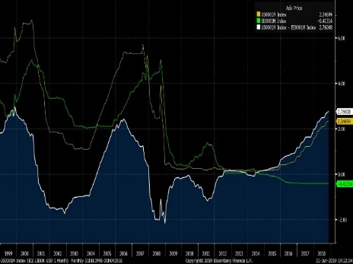

< interest rate differential > < forward premium >

(GBP)

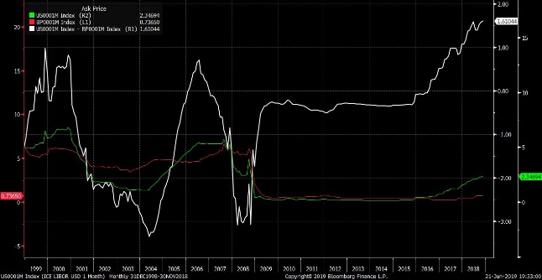

< interest rate differential > < forward premium >

(CHF)

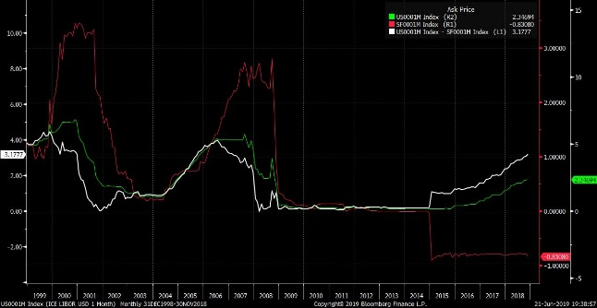

< interest rate differential > < forward premium >

JPY’s () also follows CIP formula, but it doesn’t show a stable pattern in crisis period. 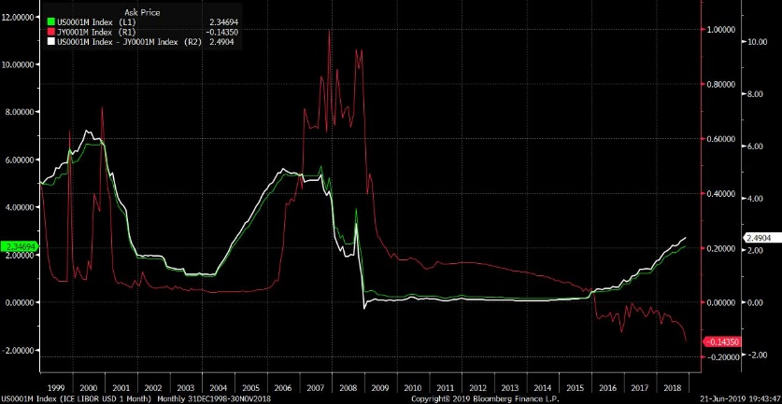

< interest rate differential > < forward premium >

KRW’s () does not seem to follow CIP.

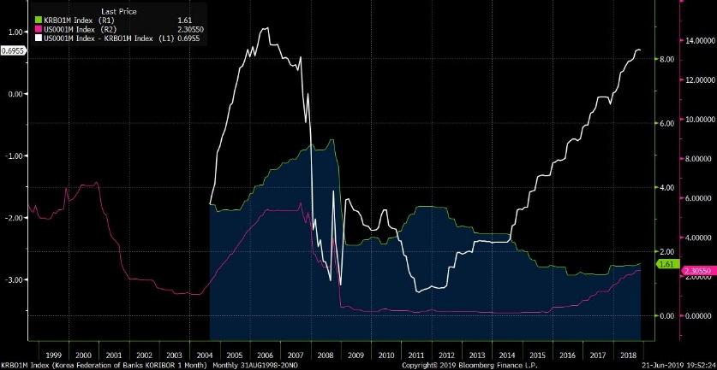

< interest rate differential > < forward premium >

The forward market rate can be explained by three main factors. First is the hedgers, who usually are firms that enter the forward market to protect themselves against the fluctuation of the exchange rates. Next is the arbitrageurs, who usually are banks, aim to make the riskless profit out of the discrepancies between interest rate differentials and forward premium/discount. Last would be the speculators who take open position in the forward market expecting that the future sport rate would turn out differently from the forward rate.

Next three categories can also be determined by which of the factors are more affecting the market.

(1) CIP satisfied, and stable premium : EURO, GBP, CHF

In Fama’s paper, three most relevant interpretations for stable premium phenomena were suggested. First was the inefficient foreign exchange expectation. This postulates that the future spot rate change expectations can be consistently perverse. In this case, the large volatility of the premium component becomes just a complementarity of the spot rate changes. However, it is somewhat peculiar that the expectation can always be consistently perverse for a long period.

Next most relevant interpretation is a time-varying premium. Large positive autocorrelation between forward and current spot rate reveals time-varying premium in the premium component of .

(2) CIP satisfied, but not stable premium : JPY

In Japan’s case, CIP stands, but the premium component is not stable.

(3) CIP not satisfied : KRW

KRW has a somewhat different story from European currencies. As mentioned in the data section, 1m forward market of KRW is divided to NDF(non-deliverable forward) market and on-shore market. The main reason it is divided into two different markets comes from the fact that KRW has not been a frequently traded currency outside of Korea. This characteristic can be applied to many other countries whose currencies are not traded frequently outside their countries.

In a situation where the price of NDFs(non-deliverable forward) follows the demand-and-supply trade-flow, the forward exchange rate may not follow the CIP formula. In forward market, theoretically, swap point quote is used to show the CIP interest differential applied in the exchange rate. If USD/KRW spot exchange rate is 1,010 won, and the swap point for 1m forward is 5 won, this means that the 1m forward rate should be 1,015 won to satisfy the non-arbitrage CIP determination. To add to this, positive swap point is called a premium, while negative swap point is called a discount. However, in reality and more frequently in emerging markets, this swap point does not always follow the CIP, but more often follows the trading flows.

Lipscomb(2005) says, “the pricing of most forward foreign exchange contracts is primarily based on the interest rate parity formula which determines equivalent returns over a set time period based on two currencies’ interest rates and the current spot exchange rate. In addition to interest rate parity calculations, many other factors can affect pricing of forward contracts such as trading flows, liquidity, and counterparty risk. NDF prices can also be affected by the perceived probability of changes in foreign exchange regime, speculative positioning, conditions in local onshore interest rate markets and the relationship between the offshore and onshore currency forward markets.” If foreign investors are hedging against the convertibility risk and buying forward, which could normally be the case, there would be a premium in NDFs. Lipscomb(2005) also finds this trend mentioning “In the case of some countries with relatively well-developed onshore currency and interest rate markets and sufficient regulatory flexibility, notably Korea and Brazil, major international banks are able to offset the currency risk of their NDF positions to some extent with onshore counterparties. NDFs nearly always trade at a premium to local market products given the lower perceived counterparty credit risk and currency convertibility risk for NDFs.” However, if the domestic export companies are hedging against the uncertainty of the dollar receivables, then there would be more short position of NDFs, dragging the price down. Also, if there is a liquidity crunch for dollar, a buy-sell method, which is borrowing dollar at current time and selling in the next period, would lower the price of NDFs. Especially, in Korea, there has been a mismatch in demand and supply for forward dollar, since ship-building and heavy industry companies always had to hedge against the forward incoming dollars, while oil-refinery companies always had to buy dollar at current period to pay for the oil. Also, the size of the domestic agents’ foreign investment and hedging(sell forward dollar) has been greater than the foreign investors’ investment in domestic market and the hedging(by forward dollar).

Another explanation for why the arbitrage demands for NDFs do not fix the NDF price at CIP rate is that arbitragers cannot be assured of profiting from the arbitrage opportunity occurred by CIP divergence, since the divergence may remain longer and even deepen.

One more interpretation that might be applied to Korea or Japan’s cases are government interventions. If government intervenes in the foreign exchange market persistently to support the currencies, the spot rate change might be influenced inversely to the market forces. Lipscomb(2005) shows how trading desks of banks take position in NDF according to their views on how the spot rate will change. Also for some countries, forward rates are seen and managed as a preliminary index for spot rates.

Lastly, applying the suggestions for negative covariance between and , KRW’s somewhat different results from European countries may have come from the fact that the volatility of was not greater than that of . When using the economic model Fama used to explain the premium(,

= [E(

= [E(+[E([1]*

=[E(+[E(

=[E(+**

[E(, which is the premium(, might not affect the as much as the European currencies do.

7. Time-varying premium and conclusion

If we exclude the possibility of irrational or perverse expectations for future spot rate changes, the time-varying premium becomes the relevant factor that may sufficiently explain the different results for previous literatures and the results here for whole period and sub-period.

For instance, in KRW and JPY case, once we exclude the period from 2007 onward, the results does show a greater variation for premium versus expected spot rate change and their negative correlations. However, the proportion of premium versus expected spot rate change seems to have fluctuated or inversed during the crisis period.

Pilbeam(2013) mentions the fluctuation of US dollar value that was $1.184/€1 in 1999 and appreciated to $0.827/€1 in 2000. It maintained around that level until it started to depreciate from $0.843/€1 in 2001 to $1.58/€1 in 2008. This big trend can be better seen as reflecting the concerns about the size of the US current account deficit as well as the US interest rate cuts to historical low. Within the period from 2001 to 2008, when US interest rates were historically low, there were premiums on the forward rates of most of the countries dealt with in this paper.

News theory of FX determination assumes that foreign exchange market is efficient, and the movement of FX follows the arrival of new information. If we adopt the news theory of FX determination, the facts discovered in this paper can be well explained. Even though the interest rate of US is low, the economic weakness of US acts as a pressure boosting other currencies and lowering US currency.

What we learn from the results of this paper is that the so called premium puzzle holds for different stages of financial periods, and still is a topic well deserved to look into.

List of Reference

Bansal, R. and Dahlquist, M., 2000, The forward premium puzzle: different tales from developed and emerging economies, *Journal of International Economics 51*, pp. 22-47.

Bilson, John F.O. 1981, The speculative efficiency hypothesis, *Journal of Business* 54, July,pp. 435-451.

Cho S. and Choi J., 2006, Time-varying risk premium and efficiency of Korean-Won/US-Dollar foreign exchange market, *Journal of Industrial Economics and Business 19(2)*, pp.701-723

Copeland, Laurence, 2008, Exchange rates and international finance,

Fama, Eugene F., 1984, Forward and spot exchange rates, *Journal of Monetary Economics* *14*, pp.319-338.

Fama, Eugene F. and Michael R. Gibbons, 1982, Inflation, real returns, and capital investment, *Journal of Monetary Economics* 9, May, pp. 297-327.

Hong, Jeong-hyo., 2018, Study on price determination in Newyork KRW-Dollar foreign exchange market, *Financial econometric study* 17(4), pp.99~118.

Hsieh, David A., 1982, Tests of rational expectations and no risk premium in forward exchange markets, *National Bureau of Economic Research working paper no.843, Jan.*

Jorda, O. and Taylor, A.M., 2012, The carry trade and fundamentals: nothing to fear but FEER itself, *Journal of International Economics* 88(1), pp. 74-90.

Johansen, S., 1988, Statistical analysis of cointegration vectors, *Journal of Economic Dynamics and Control* 12, pp. 231-254.

Lipscomb, L., 2005, An overview of non-deliverable foreign exchange forward markets, *Federal Reserve Bank of New York*

Olmo, J. and Pilbeam, K.,2011, Uncovered interest parity and the efficiency of the foreign exchange market : a re-examination of the evidence, *International Journal of Finance and Economics 16*, pp.189-204.

Pilbeam, Keith, 2013, International Finance,

Thornton, D., 2019, Resolving the unbiasedness and forward premium puzzles*, Scottish Journal of Political Economy 66(1)*, 5-27.

2. Is there a smart money effect in UK mutual funds?

1. Introduction

Value for money is what every investors are looking for. With the purpose of increasing wealth, investors choose among arrays of investment vehicles. Amongst these investment options, mutual funds in size have grown tremendously in the 80’s and 90’s(Gruber 1996). However, the average alphas for mutual funds when Fama-French 3 factor or 4 factor models are applied are negative according to study conducted by Gruber(1996), Sapp and Tiwari(2004). Against the backdrop of the growth of mutual funds and the average underperformance of them, we logically start thinking that a very few funds may have positive alphas or better performances, where most of the money flows money should be directed to. As Keswani(2008) once said, even with 95 bad performance funds, if 5 good performance funds are receiving most of the money flows, then the society as a whole does not need to be too alerted about this overall bad performance.

Subsequently following issue is whether there is a so called ‘smart money effect’. If a few funds are receiving more of the money flows, does this signal a better performance in the next term? With restricted information to evaluate actively managed funds, this signal of smart money could be a very reliable beckoning signal for many investors.

In this research paper, I will verify if the net cash flows in UK actively managed mutual funds have correlations with the performance in the next term. I will restrict my research universe into performance and attributes of UK funds from 2015 to 2017.

# 2. Literature review

Gruber(1996) studied whether investors are capable of finding performing funds and could put new cash flows into them. Gruber(1996) asserts that since the management ability is not priced in the net value of a fund, performance could be predictable, consequently sparking new cash flows into the better predicted funds. Eventually, he suggested that funds with new cash flows would perform better.

Zheng(1996) raised questions whether investors can forecast mutual fund performance by looking into Gruber(1996)’s ‘smart money effect’ and information effect(whether investor’s decisions have made abnormal returns). He found that there were positive smart money effect in the short term.

Sapp and Tiwari(2004) continued the study on smart money effect and raised question as to the exposure to momentum. They studied whether the fund managers or investors were chasing momentum styles(therefore deliberately selecting) or just following the winner funds. They left the question of smart money and the ability of investors(or institutions) back onto the table.

# 3. Data collection

There were two data-sets needed for this research. The first was a dataset to obtain the alphas of the chosen UK funds. I accessed and used the monthly Fama-French 4 factors data from the University of Exeter(UK) Business school, Xfi Center for Finance and Investment website. To specify, I downloaded the monthly momentum factors that included SMB(Small minus Big), HML(High-book-value minus Low value), UMD(Up minus Down). I used 36 months factor data from 2015 January to 2017 December and used the same period monthly return of the funds downloaded from the Morningstar Direct(which I will explain how I accessed in the following paragraph).

Table 1 Dataframe for alpha calculation

|  |  |  |  |  |  |  |
| --- | --- | --- | --- | --- | --- | --- |
| Name | date | rm-rf | smb | hml | umd | R(fund)-rf |
| Aberdeen Global UK Eq A Acc GBP | 2015-01 | 0.026 | -0.032 | -0.023 | 0.033 | 0.033 |
| Aberdeen Global UK Eq A Acc GBP | 2015-02 | 0.037 | 0.014 | 0.032 | -0.055 | 0.032 |
| Aberdeen Global UK Eq A Acc GBP | 2015-03 | -0.017 | 0.021 | -0.014 | 0.052 | -0.008 |
| Aberdeen Global UK Eq A Acc GBP | 2015-04 | 0.030 | -0.002 | 0.016 | -0.056 | 0.033 |
| Aberdeen Global UK Eq A Acc GBP | 2015-05 | 0.013 | 0.038 | -0.022 | 0.026 | 0.029 |
| Aberdeen Global UK Eq A Acc GBP | 2015-06 | -0.058 | 0.046 | -0.012 | 0.003 | -0.073 |
| ….(continued) | … | … | … | … | … | … |

I calculated alphas of each of the funds for year 2015 to 2017, by regressing 12 months factors with 12 months fund returns, and converted the monthly alphas to annualized alphas. I constructed the dataframe for alphas with a separate column for time, so that I could easily merge with the flow data which will be explained again next.

Table 2 Calculated alphas

|  |  |  |
| --- | --- | --- |
| Name | time | alpha |
| Aberdeen Global UK Eq A Acc GBP | 1 | -0.04287 |
| Aberdeen Global UK Eq A Acc GBP | 2 | -0.03466 |
| Aberdeen Global UK Eq A Acc GBP | 3 | -0.01757 |
| Aberdeen Global UK Eq A SInc GBP | 1 | -0.04284 |
| Aberdeen Global UK Eq A SInc GBP | 2 | -0.03461 |
| Aberdeen Global UK Eq A SInc GBP | 3 | -0.01754 |
| …(continued) | … | … |

The second dataset on the flows and sizes of the funds was retrievable from Morningstar Direct. With City University student account. I logged in through a terminal to access the database, and set my preference for UK, active management and open ended funds. In order to narrow down the funds to equity based, I used the ‘Morningstar Category’ and chose equity based funds that invested in UK equities. The reason I chose ‘Morningstar Category’ in preference to ‘Global Broad Category Group’ or ‘Global Category’ was that Morningstar Category had the most detailed category to pinpoint the equity related funds. I chose ‘Large cap’, ‘Medium and small cap’ and ‘Equity income’ funds ending up with 2,335 funds. I included Equity Income funds, since they invests in dividends coming from UK equities and could be regarded as equity funds.

Since the basic ‘Snap Shot’ data points provided by Morningstar Direct didn’t give enough data points, I had to insert some Custom data points. After choosing the ‘Edit Data’ on Morningstar command panel, I chose ‘Custom Calculations’ to make my own calculation for the new data points. By choosing ‘Last Value’ among the ‘Custom Calculation data points’, and choosing the ‘Fund Size-surveyed(monthly)’ for the Source data, and lastly ticking ‘Forward extending window’ for the Calculation window, I was able to get 3 years data on the fund size and annual returns. I also downloaded monthly returns to calculate the alphas in combination with the Fama French factors retrieved beforehand(which was explained in the former paragraph). After I got the fund size and annual returns, I was able to produce net flows of the funds for each year by using a calculation method.

Table 3 Net flows

|  |  |  |  |  |
| --- | --- | --- | --- | --- |
| Name | time | Flow | size | lsize |
| Aberdeen Global UK Eq A Acc GBP | 1 | 949567.1 | 35301965 | 35802320 |
| Aberdeen Global UK Eq A Acc GBP | 2 | -3013407 | 37330313 | 35301965 |
| Aberdeen Global UK Eq A Acc GBP | 3 | -4070277 | 37296568 | 37330313 |
| Aberdeen Global UK Eq A SInc GBP | 1 | 949122.9 | 35301965 | 35802320 |
| Aberdeen Global UK Eq A SInc GBP | 2 | -3015416 | 37330313 | 35301965 |
| Aberdeen Global UK Eq A SInc GBP | 3 | -4071155 | 37296568 | 37330313 |

Lastly, I needed to merge the first dataset(alphas) with the second dataset(flow and size). After merging them on same name and time, I was finally left with 1,669 funds. Missing cells were those without alphas, fund sizes or returns. All my data processing was done by using R program. The final dataframe I achieved had columns such as Name, time, flow, lagged flow, %flow, lagged %flow, alpha, lagged alpha, fund size, lagged fund size. Time column would initially include time 1(2015), but since my regression model would use lagged flows as independent variables, I got rid of the data with time 1(which does not have lagged data) and used data on time 2(2016) and 3(2017). The final dataframe left was 1,669 funds with 3,338 rows of observations.

Table 4 Final dataframe

|  |  |  |  |  |  |  |  |  |  |
| --- | --- | --- | --- | --- | --- | --- | --- | --- | --- |
| Name | time | Flow | lFlow | alpha | lalpha | PFlow* | lPFlow** | size | lsize |
| Aberdeen Eq A | 2 | -3013407 | 949567.1 | -0.03466 | -0.04287 | -0.08536 | 0.026523 | 37330313 | 35301965 |
| Aberdeen Eq A | 3 | -4070277 | -3013407 | -0.01757 | -0.03466 | -0.10903 | -0.08536 | 37296568 | 37330313 |
| Aberdeen Eq B | 2 | -3015416 | 949122.9 | -0.03461 | -0.04284 | -0.08542 | 0.02651 | 37330313 | 35301965 |
| Aberdeen Eq B | 3 | -4071155 | -3015416 | -0.01754 | -0.03461 | -0.10906 | -0.08542 | 37296568 | 37330313 |
| Aberdeen Eq X | 2 | -3320880 | 690883 | -0.02727 | -0.03567 | -0.09407 | 0.019297 | 37330313 | 35301965 |
| Aberdeen Eq X | 3 | -4379606 | -3320880 | -0.0103 | -0.02727 | -0.11732 | -0.09407 | 37296568 | 37330313 |
| ···(continued) | ··· | ··· | ··· | ··· | ··· | ··· | ··· | ··· | ··· |

*‘PFlow’ : Percentage flow, ** ‘lPFlow’ : Lagged percentage flow

# 4. Data characteristic

It was critical to make sure that all the data were processed properly into relevant rows and columns of the dataframe, since there were many funds that had similar names(even same names) and a lot of different dataset had to be merged into one comprehensive dataframe. I checked some of the variables’ density distribution as well as summary.

## (1) Lagged flow

The distribution of Lagged Flow can be seen in the underneath density graph as well as in the table below. Here, I checked the basic distribution and whether there were any unaccountable outliers. The lagged flows were seen to be within reasonable range.

Figure 1 Lagged flow distribution

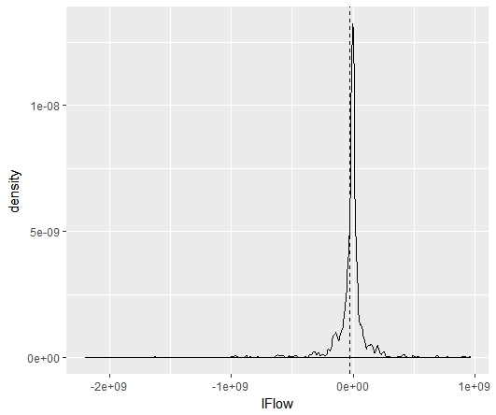

|  |  |  |  |  |  |
| --- | --- | --- | --- | --- | --- |
| Min | 1st Quantile | Median | Mean | 3rd Quantile | Max |
| -2.489e+09 | -7.572e+07 | -1.659e+07 | -5.770e+07 | 6.934e+05 | 1.017e+09 |

## (2) Lagged percentage flow

Percentage flows were calculated by deviding current Flow by lagged size. However, if a fund has just recently launched, the percentage flow could become extremely big, which distorts the analysis.

Table 5 Abnormal fund size

|  |  |  |  |
| --- | --- | --- | --- |
| Name | Size(2014) | Size(2015) | Size(2016) |
| Lazard UK Omega A Acc | 1,725,002.00000 | 82,114,089.00000 | 92,128,161.00000 |
| Lazard UK Omega A Inc | 1,725,002.00000 | 82,114,089.00000 | 92,128,161.00000 |
| Lazard UK Omega B Acc | 1,725,002.00000 | 82,114,089.00000 | 92,128,161.00000 |

Figure 2 Lagged %Flow distribution

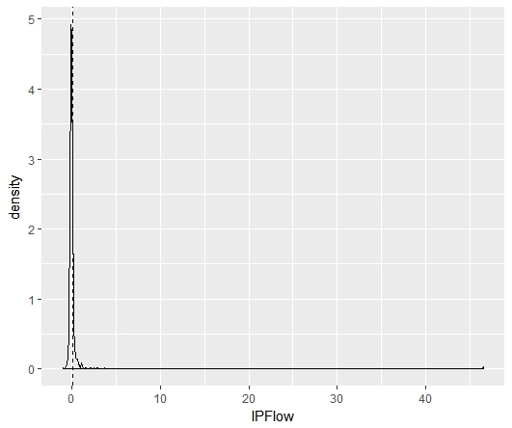

|  |  |  |  |  |  |
| --- | --- | --- | --- | --- | --- |
| Min | 1st Quantile | Median | Mean | 3rd Quantile | Max |
| -1.07742 | -0.15499 | -0.08638 | 0.07591 | 0.00469 | 46.59187 |

The Max value of 46.59 comes from the Lazard UK Omega funds’ small size in 2014, followed by its fast growth. There were nine funds with extremely small sizes in 2014: six ‘Lazard UK Omega’ funds(lagged Percentage flow of 46.59) and three ‘Kames UK Smaller Companies’ funds(lagged Percentage flow of 16.5). The 10th fund’s lagged percentage flow seems to be within normal range, with its value at 5.4. These outliers may skew the results when included in regression test. So during regression, I will do an alternative test with these outliers excluded.

## (3) Alpha

Distribution of alphas seemed to be in the proper range. There does not seem to be extreme outliers in the alphas, and most of the data centered around zero. The highest alpha of 0.346 was attained by Tosca Micro Cap UCITS fund, followed by Elite Webb Cap Smaller fund’s 0.343. The lowest alpha of -0.190 was recorded by SLI UK Equity Recovery Ret Acc fund, followed by Allianz UK Mid Cap fund’s -0.183.

One thing to note is that the alphas are calculated after considering the momentum effects. Using Fama-French 4 factor that adds UMD(Up-minus-Down) as a variable takes momentum effect into consideration.

Figure 3 alpha distribution

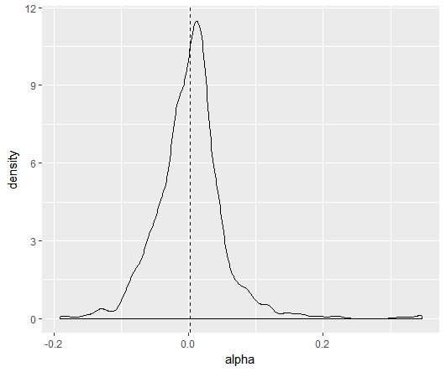

|  |  |  |  |  |  |
| --- | --- | --- | --- | --- | --- |
| Min | 1st Quantile | Median | Mean | 3rd Quantile | Max |
| -0.190453 | -0.024151 | 0.003795 | 0.002220 | 0.025417 | 0.346108 |

5. Test for smart money

First, I conducted test for smart money by looking at the signs of the net flows. By comparing the average alphas of the positive net flows and negative flows, I found that positive flows have higher alphas. The difference was 0.0032. However, with value-weighted average, the difference became more blatant at 0.0136. With the value weighted method, the average alpha for negative flow turned to a negative sign and the average alpha for positive flow grew bigger from 0.00459 to 0.01066. The results are the same for the percentage flows since the signs are only divided by +/- just as the net flows are.

|  |  |  |  |  |  |
| --- | --- | --- | --- | --- | --- |
| Type | Weight | Sign | Count | Average Alpha | Alpha difference |
| Net flow  (=%flow) | Equal | Negative | 2472 | 0.00138 | 0.0032 |
| Positive | 866 | 0.00459 |
| Net flow  (=%flow) | Value weighted | Negative | 2472 | -0.00298 | 0.0136 |
| Positive | 866 | 0.01066 |

Second test was to compare high positive flows with low positive flows, as well as high positive flows in percentage with low positive flows in percentages. For this comparison, I divided the groups by median value(not the average value), since the average was too much skewed towards the extreme end values. The results for net flow and percentage flow are different, since the median values are different for the two groups. It shows that there are smart money effect, however the difference in alpha seemed to have become much smaller than when we compared ‘positive vs. negative.’ The difference in alpha became a bit bigger when we used net flow in value weighted or when we used percentage flows in equal weighted.

| Type | Weight | Sign | Count | Average Alpha | Alpha difference |
| --- | --- | --- | --- | --- | --- |
| Net flow | Equal | Low positive | 433 | 0.00453 | 0.00011 |
| High positive | 433 | 0.00464 |
| Value weighted | Low positive | 433 | 0.00896 | 0.00218 |
| High positive | 433 | 0.01114 |
| Percentage  Flow | Equal | Low positive | 433 | 0.00079 | 0.00380 |
| High positive | 433 | 0.00459 |
| Value  Weighted | Low positive | 433 | 0.01046 | 0.00048 |
| High positive | 433 | 0.01094 |

The last test was to compare high negatives with low negatives. Here, I need to state that ‘high negative’ is smaller in value than ‘low negative.’ All the results show that there are smart money effect. However, the result from percentage flow with value-weighted method shows the biggest alpha difference of 0.01756.

|  |  |  |  |  |  |
| --- | --- | --- | --- | --- | --- |
| Type | Weight | Sign | Count | Average Alpha | Alpha difference |
| Net flow | Equal | High negative | 1236 | -0.00056 | 0.00390 |
| Low negative | 1236 | 0.00334 |
| Value weighted | High negative | 1236 | -0.00411 | 0.00836 |
| Low negative | 1236 | 0.00425 |
| Percentage  Flow | Equal | High negative | 1236 | -0.00106 | 0.00489 |
| Low negative | 1236 | 0.00383 |
| Value  Weighted | High negative | 1236 | -0.01196 | 0.01756 |
| Low negative | 1236 | 0.00560 |

6. Regression tests

For regression test, I used three models with different variables. All the dependent variables are alpha. The first model is a one-factor model with only lagged flow variable. The second has additional variable of lagged alpha. The last model has lagged size variable in addition to the two variables applied in the second one. For the regression test, I used percentage flows as well as net flows. Again, the dataframe(table 5) is the one I used for regression.

①

②

③

## (1) Regression test 1 :

First, I conducted regression test 1 with the lagged net flow. Summary of the regression and its plot chart with regression line are shown below. The coefficient for lagged flow is positive and significant, showing smart-money effect.

|  |
| --- |
| Coefficients:  Estimate Std. Error t value Pr(>|t|)  (Intercept) 3.010e-03 9.088e-04 3.311 0.000938***  Total1$lFlow 1.386e-11 4.111e-12 3.327 0.000886***  Multiple R-squared: 0.003308, Adjusted R-squared: 0.003009  F-statistic: 11.07 on 1 and 3336 DF, p-value: 0.0008861  Signif. codes:  0 ‘*** ’0.001 ‘**’ 0.01 ‘*’ 0.0 ‘.’ 0.1 ‘ ’ 1 |

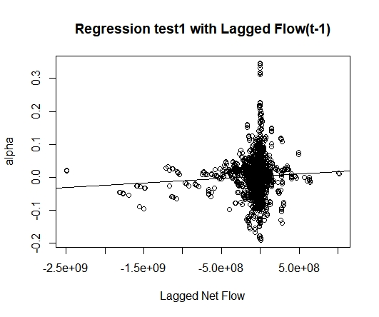

Next, I conducted the same regression test1 again with lagged percentage flows.

|  |
| --- |
| Coefficients:  Estimate Std. Error t value Pr(>|t|)  (Intercept) 1.794e-03 0.0008794 2.535 0.0113*  Total1$lPFlow -0.0001146 0.0004236 -0.271 0.7868  Multiple R-squared: 2.194e-05, Adjusted R-squared: -0.0002778  F-statistic: 0.0732 on 1 and 3336 DF, p-value: 0.7868  Signif. codes:  0 ‘*** ’0.001 ‘**’ 0.01 ‘*’ 0.0 ‘.’ 0.1 ‘ ’ 1 |

Surprisingly, the significance disappeared with lagged percentage flows, which could very much be explained by the outliers in the lagged percentage flows. As I mentioned in the data character chapter, the huge percentage flows coming from Lazard and Kames new funds may have distorted the result.

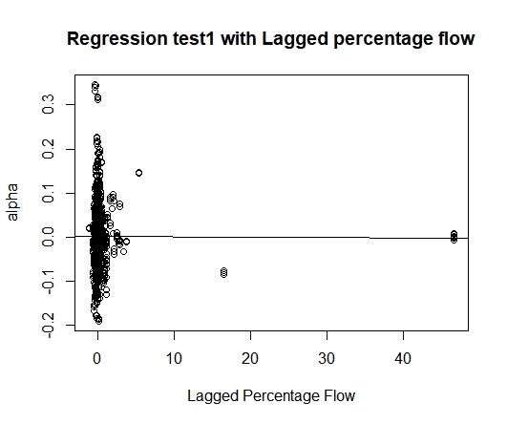

Therefore, I ran an alternative regression test1 with lagged percentage flows without the outliers. The three outliers with lagged percentage flows of 16.5 were Kames UK Smaller Companies funds, and the six outliers at 46.59 were Lazard UK Omega funds. The results without outliers were more significant and pronounced. It shows that with 1% more of lagged percentage flow, the alpha would increase 0.0053 or 0.53%.

|  |
| --- |
| Coefficients:  Estimate Std. Error t value Pr(>|t|)  (Intercept) 0.0024196 0.0008807 2.747 0.00604**  Total1_mod$lPFlow 0.0053626 0.0021718 2.469 0.01359*  Multiple R-squared: 0.001829, Adjusted R-squared: 0.00152  F-statistic: 6.097 on 1 and 3327 DF, p-value: 0.01359  Signif. codes:  0 ‘*** ’0.001 ‘**’ 0.01 ‘*’ 0.0 ‘.’ 0.1 ‘ ’ 1 |

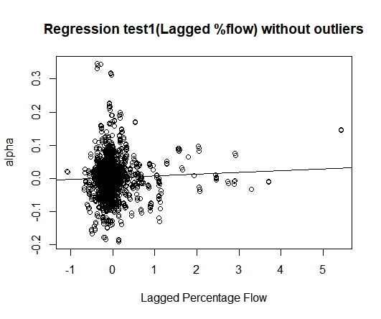

## (2) Regression test 2 :

From regression test 2 and onwards, I used the modified dataframe without the outliers. The number of funds are still 1,669, but the number of rows within the dataframe is reduced from 3,338 to 3,329. As with the regression test1, I found positive and significant coefficient for lagged flow. Coefficient for lagged alpha was positive but not significant.

|  |
| --- |
| Coefficients:  Estimate Std. Error t value Pr(>|t|)  (Intercept) 2.777e-03 9.422e-04 2.947 0.003236**  Total1_mod$lFlow 1.376e-11 4.134e-12 3.329 0.000881***  Total1_mod$lalph 2.333e-02 1.590e-02 1.467 0.142419  Multiple R-squared: 0.004263, Adjusted R-squared: 0.003665  F-statistic: 7.12 on 2 and 3226 DF, p-value: 0.0008208  Signif. codes:  0 ‘*** ’0.001 ‘**’ 0.01 ‘*’ 0.0 ‘.’ 0.1 ‘ ’ 1 |

Alternative regression test2 with lagged percentage flows shows the underneath results. The coefficient and significance level for lagged percentage flow are similar to the values derived in regression test1. It is worthy to note the significance became much smaller(less significant) with percentage flows.

|  |
| --- |
| Coefficients:  Estimate Std. Error t value Pr(>|t|)  (Intercept) 0.0021138 0.0009113 2.320 0.0204*  Total1_mod$lPFlow 0.0047790 0.0022172 2.155 0.0312*  Total1_mod$lalpha 0.0211016 0.0161815 1.304 0.1923  Multiple R-squared: 0.002339, Adjusted R-squared: 0.001739  F-statistic: 3.899 on 2 and 3326 DF, p-value: 0.02035  Signif. codes:  0 ‘*** ’0.001 ‘**’ 0.01 ‘*’ 0.0 ‘.’ 0.1 ‘ ’ 1 |

## (3) Regression test 3 :

Now with lagged size added to the list of independent variables, the significance for lagged flow’s coefficient became lower. Neither of lagged alpha nor of lagged size had significant relation with alpha.

|  |
| --- |
| Coefficients:  Estimate Std. Error t value Pr(>|t|)  (Intercept) 2.381e-03 1.022e-03 2.331 0.01982*  Total1_mod$lFlow 1.702e-11 5.265e-12 3.233 0.00124**  Total1_mod$lalph 2.275e-02 1.591e-02 1.430 0.15279  Total1_mod$lsize 8.251e-15 8.259e-13 0.999 0.31780  Multiple R-squared: 0.004562, Adjusted R-squared: 0.003664  F-statistic: 5.08 on 3 and 3225 DF, p-value: 0.001648  Signif. codes:  0 ‘*** ’0.001 ‘**’ 0.01 ‘*’ 0.0 ‘.’ 0.1 ‘ ’ 1 |

Alternative test with lagged percentage flow shows the next results.

|  |
| --- |
| Coefficients:  Estimate Std. Error t value Pr(>|t|)  (Intercept) 2.681e-03 1.025e-03 2.615 0.00895**  Total1_mod$lPFlow 4.695e-03 2.218e-03 2.116 0.03438*  Total1_mod$lalph 2.069e-02 1.618e-02 1.278 0.20119  Total1_mod$lsize -7.845e-13 6.494e-13 -1.208 0.22714  Multiple R-squared: 0.002777, Adjusted R-squared: 0.001877  F-statistic: 3.086 on 3 and 3325 DF, p-value: 0.02618  Signif. codes:  0 ‘*** ’0.001 ‘**’ 0.01 ‘*’ 0.05 ‘.’ 0.1 ‘ ’ 1 |

# 7. Test and Regression results explanation

The comparison of average alphas between groups of funds showed that the results accorded with the existence of smart money. I summarized three different value-weighted alpha comparisons based on the lagged percentage flows. All the tests proved smart money effect, and it is quite obvious that positive flows have higher alphas than negative flows. However, it was in the negative flows(High vs. Low) that showed more smart money effect. It could be understood from the viewpoint that positive flows could have mixed in-and-out flows while negative flows have one-sided out-flows. Once a fund has over performed, investors may withdraw money out of it as well as pour more into it, in order to realize their returns. However, in the negative side, money flow could more tend to be one sided.

Table 6 Summary of average alpha comparison

|  |  |  |  |  |
| --- | --- | --- | --- | --- |
| Type | Sign | Count | Average Alpha | Alpha difference |
| Neg. vs. Pos. | Negative | 2472 | -0.00298 | 0.0136 |
| Positive | 866 | 0.01066 |
| Low pos vs. High pos. | Low positive | 433 | 0.01046 | 0.00048 |
| High positive | 433 | 0.01094 |
| High neg vs. Low neg. | High negative | 1236 | -0.01196 | 0.01756 |
| Low negative | 1236 | 0.00560 |

The table below shows the coefficient values and p-values of each regression results. Since I focused to find smart money effect, I made this table centered around the coefficients of net flows(lagged) and %flows(lagged). All the results show positive signs for the coefficients and significance at 0.001 or 0.05 level. Overall, for ￡1,000,000,000 additional inflow of money there would be about 1.3% to 1.7% increase of alpha. For 1% of additional inflow(compared to the size of fund), there would be about 0.47% to 0.53% increase of alpha.

Table 7 Summary of regression test

|  |  |  |  |
| --- | --- | --- | --- |
| Regression model | Flow type | coefficient | Significance(p-value) |
| 1 | Net flow | 1.386e-11 | 0.000886*** |
| 1 | % flow | 0.0053626 | 0.01359* |
| 2 | Net flow | 1.376e-11 | 0.000881*** |
| 2 | % flow | 0.0047790 | 0.0312* |
| 3 | Net flow | 1.702e-11 | 0.00124** |
| 3 | % flow | 0.004695 | 0.03438* |

It might be worthy to note that lagged net flows had more significance than the lagged percentage flows. This may be interpreted that it is the momentum of the flow that is predicting the performance of the fund, not the proportional flow of the money compared to the size of the fund.

All in all, the results coincides with the smart money. However, there is one caveat to note. Although I got rid of 9 extreme data rows that had minimal fund size in 2014 in order to exclude %flows that had values higher than 16(1,600%), there could be meaningless data within the 1 to 16(100~1600%) range also. MI Chelverton UK Equity Growth fund with lagged %flow of 5.42(542%), the highest after nine outliers were eliminated, could also be checked, however in my study I kept it in the dataset. I could not profess that the erased outliers would either strengthen the smart money effect or not. The eliminated Lazard Omega UK funds had mixed records; some being positive and some negative. This note may well be applied to the negative flow side also. If a fund is already known to be ousted from the market but continues to be on the market for a couple of more years, huge outflow of money and continuing negative alphas are quite predictable. Therefore, to conduct a more robust study, a closer look into the funds’ life cycle would be required.

# 8. Summary

The main purpose of this research was to verify if the posits of preceding literatures and the idea that performing mutual funds have their signals called smart money would hold in UK funds.

From the 2,335 UK mutual funds in Morningstar Direct, 1,669 funds with 3,338 rows of observation from time 2(2016) and time 3(2017) were obtained. However, nine extremely low observations with net flows had to be eliminated for a more robust test. All the basic tests comparing the average alphas proved smart money effect, and the average alpha difference between positive and negative flows was 1.36%. It was worthy to keep in mind that it was in the negative flows that showed more smart money effect. Regression tests also showed that Lagged net flow or Lagged percentage flow had positive effect and the coefficients were all significant. However, the results show that the impact of net flow was more significant than the proportionate percentage flow compared to the size of the fund.

Interpretations of this research may be limited, however, they are in align with the existence of smart money effect, and may work as a basis for further research.

List of references

1. Gruber, Martin J., 1996, Another puzzle : The growth in actively managed mutual funds, *Journal of Finance 51(3)*, pp. 783-810.

2. Zheng L., 1999, Is Money Smart? A study of mutual fund investors’ fund selection ability, *Journal of Finance 54(3)*, pp. 901-933.

3. Sapp T. and Tiwari A., 2004, Does stock return momentum explain the “smart money” effect? *Journal of Finance 59*, pp. 2605-2622.

4. Keswani A. and Stolin D., 2008, Which money is smart? Mutual fund buys and sell of individual and institutional investors *Journal of Finance 63(1),* pp. 85-118.

1. Assuming interst rate parity(IRP) in open international bond markets,  
    / = (/(1+  
    : forward exchange rate(units of currency i for unit of currency j)  
    : spot exchange rate  
    : nominal interest rates observed at t on discounted bonds denominated in currency i  
    : nominal interest rates observed at t on discounted bonds denominated in currency j